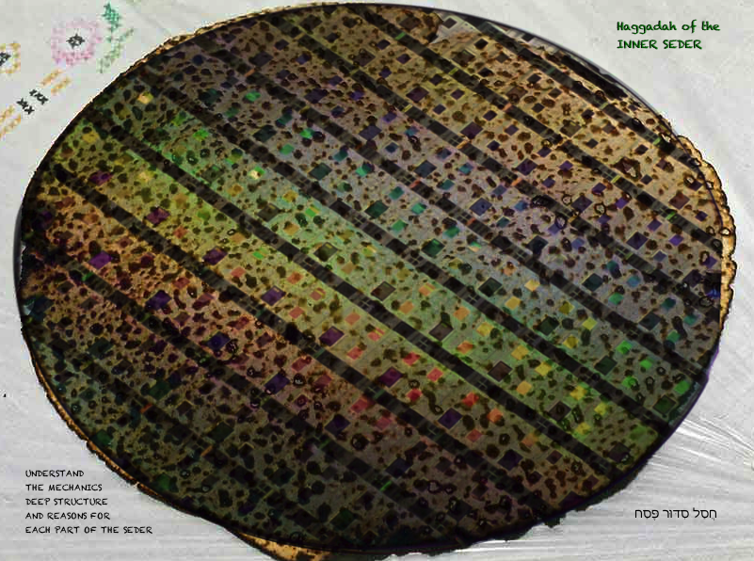
The 2026 edition of the Haggadah of the Inner Seder is dedicated to the memory of Awdah al-Hathaleen, gunned down by an extremist settler in Umm al-Kheir, to the bravery and summud of the Palestinians resisting ethnic cleansing in the West Bank, and to the courage of all Israelis and Jews from other nations and all internationals who are standing in the breach to stop extremist settler violence, by doing “protective presence”.
May Hashem protect them from violence, and ruin the plans of those who seek to harm them.

תְעַקֵּר טִירוּנִיָא וָעָרִיצוּת וּתְשַׁבֵּר רַמַאִים
וּתְמַגֵּר עֹשְׁקֵי נִדְכָּאִים
תַעֲבִיר מֶמְשֶׁלֶת זָדוֹן מִן הָאָרֶץ
תַּכְשִׁיל פּוֹגְעִים בְּדֵמוֹקרָטִיָה וְתָּפֵר תַחְבּוּלוֹתָם
תְכַלֵּם וְתַשְׁפִּילֵם וְתַכְנִיעֵם
בִּמְהֵרָה בְיָמֵינו
תִּתֵּן לְכָל אֻמּוֹת הָעוֹלָם הָכֹּחַ וְהַרָצוֹן
לִרְדֹף צֶדֶק וּלְבַקֵּשׁ שָׁלוֹם כְּאַגֻדָה אַחַת
לֲעַקֹר חָמָס וּלְהַצְמִיחַ רְפוּאָה וְחַיִים טוֹבִים וְשָׁלוֹם
כִּי אַתָּה הוּא מֶֽלֶךְ אֹהֵב צְדָקָה וּמִשְׁפָּט

For solidarity between Jews and Palestinians, this Haggadah suggests adding hyssop (za’atar) to your karpas, to remember the connection both peoples have to the land of the promise. You can use a sprig of oregano or thyme if you cannot find hyssop. Olives also work. For Jews, hyssop (eizov) purified, and it was used to paint blood on the doorways before the plague of the firstborn. For Palestinians, za’atar is a symbol of steadfastness because it can grow anywhere, and it’s an essential spice.
You will find many Sephardi and Mizrachi customs in this haggadah, along with questions and teachings related to human rights and to earth-based practices. For more Passover resources, including the Omer Counter app, go to: neohasid.org/zman/pesach/
We must never forget that Hamas came to power because Netanyahu supported them as a way to politically divide the Palestinian people. Standing up for the Palestinian people requires standing up against Hamas and against Netanyahu. Standing up for Israel’s people, Jewish and Palestinian, requires the same. For prayers on behalf of all the peoples and lands of Israel and Palestine, see: neohasid.org/resources/Prayer-state/ and for actions visit standingtogether.org/en or facebook.com/standingtogetherenglish/. The prayer for democracy above can be downloaded with translation at neohasid.org.
A few days after this edition of the haggadah went online, the Knesset passed a law for a death penalty for Palestinian terrorists, but not for Jewish terrorists. In addition to the horror of the death penalty in general, this violates the fundamental Torah principle of one law for community and stranger (Exod 12:49 and Lev 24:22 and Num 15:16). That principle is one of the conditions of the covenant that is the basis for connection between the Israelites and the land. The covenantal cost of violating that principle is exile. This law is not referenced directly in the haggadah, but where those verses are mentioned, that can be an opportunity for discussing it if you choose.
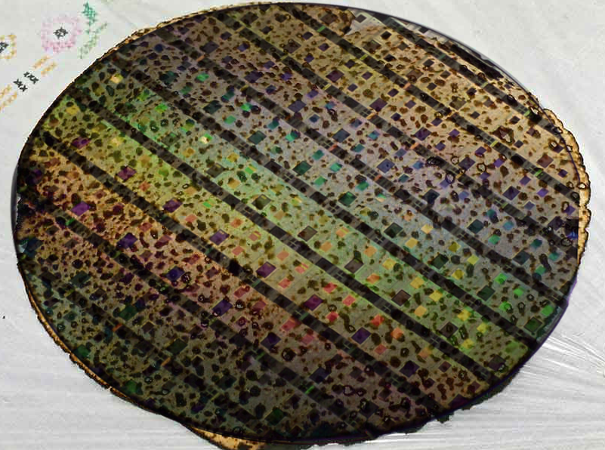  Haggadah of the Inner Seder  This haggadah is provided under a collective commons license: use, share, or modify, but please mention the source: R. David Seidenberg, neohasid.org.  2026 edition | This haggadah is focused on revealing the inner structure of the seder.  The traditional haggadah includes many fours beyond the obvious four cups, four children, and four questions.  The most important may be the four times matsah is used. Other examples include the four verses from Deuteronomy that the haggadah interprets, the four times we explain Exodus 13:8 (Ba`avur zeh – see pp.6 and 13), and the four times we begin telling the story. The transformation of the meaning of Ba`avur zeh is particularly stunning.  This haggadah follows the rules for quotes called “logical punctuation”. | This font is used for the steps.  This font is used for other headings and for descriptions of how to do the seder and for customs, including explaining why we do things in a certain way.  This font is used for the translation of the haggadah text. Italics are used for Scripture and for transliteration.  This font and this font are used for text commentary and interpretation.  > Prayers and comments related to protecting the Earth.  > Political commentary related to refugees or to Israel.  > Questions and reflections related to other contem-porary issues, especially wars and democracy. |  | The seder (which means “order”) is literally an ordering of symbols so that they progress from slavery to freedom. So, for example, matsah can symbolize slavery, leaving Egypt, coming into the land, and messianic redemption. But on seder night, we first experience it as the bread of slavery (lachma anya), and end by experiencing it as the bread of redemption (afikoman). This transformation is the essence of the seder.
Bedikat Chamets  After the search for Chamets the night before Passover, say the following formula. You may also add this Earth prayer from neohasid.org. | “All the chamets that is in my possession/r’shut, which I [did see or] did not see and which I [did remove or] did not remove, let it be nullified and let it become like the dirt of the earth/afra d’ar’a.”  Kol chamira v’chami`a d’ika bir’shuti [d’chaziteih u]d’la chaziteih, [d’vi`arteih u]d’la vi`arteih liv’til v’lehevei (hefker) k`afra d`ar`a.  (Add the words in brackets in the morning, when you burn the chamets.)  >May we remember on this day that just as we do not own this chamets, we do not own this Earth. May we recall that Adam, the human, is made of afar min ha’adamah, soil, dirt from the ground, and that we belong to the soil. May we cherish the soil that comes from millenia of rocks breaking and life growing and decomposing. We too are “hewn from the rock and dug from the mine” of Abraham and Sarah (Isaiah 51:1-2). And so, may it be Your will, Adonai Eloheinu, that we give truth to Your promise to Abraham, that his progeny would become “like the soil of the earth, ka`afar ha’arets” (Genesis 13:16) – k`afra d’ar’a – and that, like the soil, we may live to nourish all Life.
The Seder steps are often sung: | Kadesh, Urchats, Karpas, Yachats; Magid, Rachtsah, Motsi, Matsah; Maror, Korekh, Shulchan Orekh; Tsafun, Barekh, Hallel, Nirtsah
Kadesh  Pour the first cup  ~  Sanctifying time  ~  Start with this paragraph on Friday night for Shabbat: | And God saw everything that God had made and here: it is very good!  And it was evening and it was morning, the sixth day. And they were completed, the heavens and the earth and all their host. And God completed in the seventh day the work that the One made, and stopped in the seventh day from all the work which the One made. And God blessed the seventh day and made him holy, for on him the One stopped from all the work which God created to do. (Genesis 1:31-2:2) |  | וַיַרְא אֱלֹהִים אֶת כָל אֲשֶר עָשָה וְהִנֵה טֹוב מְאֹד  וַיְהִי עֶרֶב וַיְהִי בֹקֶר יוֹם הַשִּׁשִּׁי. וַיְכֻלּוּ הַשָּׁמַיִם וְהָאָרֶץ וְכָל-צְבָאָם. וַיְכַל אֱלֹהִים בַּיּוֹם הַשְּׁבִיעִי מְלַאכְתּוֹ אֲשֶׁר עָשָׂה וַיִּשְׁבֹּת בַּיּוֹם הַשְּׁבִיעִי מִכָּל מְלַאכְתּוֹ אֲשֶׁר עָשָׂה. וַיְבָרֵךְ אֱלֹהִים אֶת יוֹם הַשְּׁבִיעִי וַיְקַדֵּשׁ אוֹתוֹ כִּי בוֹ שָׁבַת מִכָּל-מְלַאכְתּוֹ אֲשֶׁר בָּרָא אֱלֹהִים לַעֲשׂוֹת. (בראשית א:לא-ב:ב) |  | This follows a custom among some Hasidim and neo-Hasidim to add the beginning of Gen. 1:31 (the first line up to “v’hineh tov m’od, it is very good!”) to Friday night kiddush.  There is a modern custom to fill each other’s wine cups instead of filling our own.

Start here on other nights: | Blessed be You, YHVH/Adonai, our God, ruler of all space-and-time, who creates the fruit of the vine.  Barukh Atah Adonai Eloheinu melekh Ha`olam borei p’ri hagafen. (Sefardim say: “hagefen”.) | בָּרוּךְ אַתָּה, יְהוָה אֱלֹהֵינוּ, מֶלֶךְ הָעוֹלָם בּוֹרֵא פְּרִי הַגָּפֶן (הַגֶּפֶן).  YHVH is traditionally pronounced “Adonai”. In Renewal Judaism it is often pronounced “Yah”. | Many preface the blessing with “Savri | סברי!”, meaning “join my intention”. One can respond “L’chayim!”, “To life!”
The holiday Kiddush  (The words in parentheses are said only on Friday night) | Blessed be You YHVH, our God, ruler of all space-and-time, who chose us from every people and exalted us from every tongue, and made us holy through God’s commandments. And You YHVH our God gave us in love (Shabbatot for rest and) celebrations for joy and seasons for rejoicing, (You gave us this Shabbat and) this holy day of matsot, season of our freedom (in love), called holy, a remembrance of going out from Egypt. For us You chose and us You made holy [from all the peoples], (and Shabbat) and the convocations of Your holiness (in love and desire,) in joy and rejoicing, you made us inherit. Blessed be You YHVH, who makes holy (Shabbat and) Israel and the seasons. | בָּרוּךְ אַתָּה, יְהוָה אֱלהֵינוּ, מֶלֶךְ הָעוֹלָם אֲשֶׁר בָּחַר בָּנוּ מִכָּל-עָם וְרוֹמְמָנוּ מִכָּל-לָשׁוֹן וְקִדְּשָׁנוּ בְּמִצְוֹתָיו. וַתִּתֶּן לָנוּ ה׳ אֱלֹהֵינוּ בְּאַהֲבָה (לשבת: שַׁבָּתוֹת לִמְנוּחָה וּ)מוֹעֲדִים לְשִׂמְחָה, חַגִּים וּזְמַנִּים לְשָׂשוֹן, (לשבת: אֶת יוֹם הַשַׁבָּת הַזֶּה וְ)אֶת יוֹם חַג הַמַּצּוֹת הַזֶּה זְמַן חֵרוּתֵנוּ, (לשבת: בְּאַהֲבָה) מִקְרָא קֹדֶשׁ זֵכֶר לִיצִיאַת מִצְרָיִם. כִּי בָנוּ בָחַרְתָּ וְאוֹתָנוּ קִדַּשְׁתָּ [מִכָּל הָעַמִּים], (לשבת: וְשַׁבָּת) וּמוֹעֲדֵי קָדְשֶׁךָ (לשבת: בְּאַהֲבָה וּבְרָצוֹן) בְּשִׂמְחָה וּבְשָׂשוֹן הִנְחַלְתָּנוּ. בָּרוּךְ אַתָּה ה׳, מְקַדֵּשׁ (לשבת: הַשַׁבָּת וְ)יִשְׂרָאֵל וְהַזְּמַנִּים. | Some emend or leave out the words “from every people” and “from every tongue”.  Much of the world’s Shmurah matsah came from Dniepro in Ukraine. Russia’s war on Ukraine shut down the world’s breadbasket. When we celebrate, how should we remember the ongoing suffering there?
Havdalah  Add this section on Saturday night (including first seder 2021).  There is no blessing for spices, since we are not leaving holy time. | Blessed be You YHVH/Adonai our God ruler of all space-and-time, who creates the shining lights of fire.  Blessed be You YHVH our God, ruler of all space-and-time, who makes separation between holy and common, between light and darkness, between Israel and the peoples, between the seventh day and the six days of doing. Between the holiness of Shabbat and the holiness of the holiday You separated, and the seventh day You made holy from the six days of doing, and you separated and made holy Your people Israel with Your holiness.  Blessed be You YHVH, who separates between holy and holy. | בָּרוּךְ אַתָּה, יְהוָה אֱלֹהֵינוּ, מֶלֶךְ הָעוֹלָם, בּוֹרֵא מְאוֹרֵי הָאֵשׁ.  בָּרוּךְ אַתָּה, יְהוָה אֱלֹהֵינוּ, מֶלֶךְ הָעוֹלָם הַמַּבְדִיל בֵּין קֹדֶשׁ לְחֹל, בֵּין אוֹר לְחשֶׁךְ, בֵּין יִשְׂרָאֵל לָעַמִּים, בֵּין יוֹם הַשְּׁבִיעִי לְשֵׁשֶׁת יְמֵי הַמַּעֲשֶׂה. בֵּין קְדֻשַּׁת שַׁבָּת לִקְדֻשַּׁת יוֹם טוֹב הִבְדַּלְתָּ, וְאֶת-יוֹם הַשְּׁבִיעִי מִשֵּׁשֶׁת יְמֵי הַמַּעֲשֶׂה קִדַּשְׁתָּ. הִבְדַּלְתָּ וְקִדַּשְׁתָּ אֶת-עַמְּךָ יִשְׂרָאֵל בִּקְדֻשָּׁתֶךָ.  בָּרוּךְ אַתָּה יְהוָה, הַמַּבְדִיל בֵּין קֹדֶשׁ לְקֹדֶשׁ. | On Saturday night, candles are traditionally lit from a flame that was burning since the beginning of the holiday and before Shabbat. Since the candles should not be put out, it works best to use shabbat candles held together, rather than a braided havdalah candle.
On both nights end Kiddush with shehechiyanu: | Blessed be You YHVH our God, ruler of all space-and-time, for you made us live and kept us sustained and let us reach this season! | בָּרוּךְ אַתָּה, יְהוָה אֱלֹהֵינוּ מֶלֶךְ הָעוֹלָם, שֶׁהֶחֱיָנוּ וְקִיְּמָנוּ וְהִגִּיעָנוּ לַזְּמַן הַזֶּה. | Barukh Atah Adonai Eloheinu melekh ha`olam shehechiyanu v’kiymanu v’higi`anu lazman hazeh.
1st cup – Kiddush | Drink the 1st cup, reclining! Each cup corresponds to one major part of the seder: Kiddush, Magid (the story), Birkat Hamazon (blessing after the meal), and Hallel (songs of praise). |  | The second cup is not filled until the four questions.
Candlelighting: Barukh Atah Yah Eloheinu Melekh/Malkat Ha’olam, asher kid’shanu b’mitzvotav v’tsivanu l’hadlik ner shel yom tov.  In years when the seder falls on a regular weeknight, some Sefardim light candles and bless them here. On Shabbat, light candles before Kiddush.  When you light, say shehechiyanu. If Passover follows Shabbat, recite blessings for wine, kiddush, candles, havdalah, shechechiyanu, in that order. |  |  |  | 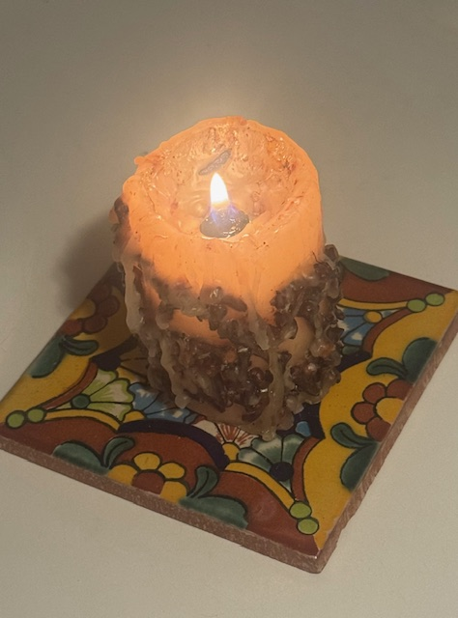
Urchats | This washing happens without a blessing. It prepares us to dip the Karpas into the salt water. You can bring a cup of water and bowl to the seder table for everyone to wash. | > Ritual handwashing elevates already clean hands. At the seder we do an extra handwashing – an even higher elevation. As we learned from the pandemic, handwashing may be for the sake of healing.
Karpas  1st dipping, in salt water |  | Blessed be You YHVH our God, ruler of all space-and-time, who creates the fruit of the ground.  A taste of spring. Some haggadot include verses from the Song of Songs about spring here. |  | בָּרוּךְ אַתָּה יְהוָה אֱלֹהֵינוּ מֶלֶךְ הָעוֹלָם בּוֹרֵא פְּרִי הָאֲדָמָה  Barukh Atah Adonai Eloheinu melekh Ha`olam borei p’ri ha’adamah. |  |  | Most Ashkenazim use parsley. Syrian Jews use celery; Russian Jews use potato. Some set out a mixture of veggies to snack on.

Hyssop > Add hyssop, known as eizov in Hebrew and za’atar in Arabic, to your karpas or seder plate, to remember the blood on the lintel that protected the firstborn, to remember that Palestinian and Israelite culture are rooted in the same land, and to hope for a future where no children are sacrificed to terror or to war. (You can also use a sprig of oregano or thyme if you cannot find hyssop.) The explanation for hyssop is found on p.5 and p.14 (after Rabban Gamliel’s three things); it can also be recited here.
Yachats  Break the middle matsah into unequal halves  The bigger half is the afikoman; the smaller half is the lechem `oni or poverty bread. |  | The afikoman is wrapped in a cloth. In the Syrian custom, each person takes a turn holding the afikoman in their right hand over their left shoulder. Then they say in Hebrew or English:  מִשְׁאֲרֹתָם צְרֻרֹת בְּשִׂמְלֹתָם עַל שִׁכְמָם בְנֵי יִשְׂרָאֵל עָשׂוּ כִּדְבַר מֹשֶׁה  Mish`arotam ts’rurot b’simlotan `al shekhmam. Uv’nei Yisrael `asu kid’var Moshe…  “Their kneading bowls/ leftover things (were) tied up in their cloaks on their shoulder. And the children of Israel did according to Moshe’s word...” (Exod. 12:34-35) |  | The whole table then asks the one holding the afikoman, in Arabic or English:  “Minwen Jaiyeh? Where are you coming from?”  She or he answers: “Mimitsrayim! From Egypt.”  All: “Lawen Raiyekh? Where are you going to?”  Answer: “Liy’rushalayim! To Jerusalem.”  All: “Ishu zawatak? What are you bringing?”  Answer: “Matsah umaror! Matsah and maror.” |  |  | Afterwards, wave the afikoman around one’s head three times and pass it onto the next person.  The Syrian Yachats custom is to break the matsah so that the bigger half is like a letter Dalet (ד – kind of like a Pacman), and the smaller half like a Yud (י). The two pieces spell Yad, for the strong hand that redeemed us.
Magid  1st time we begin to tell the story  1st explanation of matsah  Hold up the smaller piece of broken matsah. |  | This is the bread of poverty, of oppression / Ha lachma `anya that our ancestors ate in the land of Egypt. Anyone hungry, they should come and eat. Anyone needing, they should come and make Pesach. Now – here. Next year – in the land of Israel. Now – slaves. Next year – freed people.  Ha lachma `anya di achalu avhatana b’ar`a d’mitsrayim. Kol dikhfin yeytei v’yeikhol. Kol dits’rikh yeytei v’yifsach. Hashata hakha, l’shanah haba’ah b’ar`a d’Yisrael. Hashata `avdei, l’shanah haba’ah b’nei (uv’not) chorin. |  | הָא לַחְמָא עַנְיָא דִּי אֲכָלוּ אַבְהָתָנָא בְאַרְעָא דְמִצְרָיִם. כָּל דִכְפִין יֵיתֵי וְיֵיכֹל, כָּל דִצְרִיךְ יֵיתֵי וְיִפְסַח. הָשַּׁתָּא הָכָא, לְשָׁנָה הַבָּאָה בְּאַרְעָא דְיִשְׂרָאֵל. הָשַּׁתָּא עַבְדֵי, לְשָׁנָה הַבָּאָה בְּנֵי וּבְנוֹת חוֹרִין.  This paragraph is in Aramaic. // It is a powerful custom to go out to the street at this point and search for anyone in need of a meal.  > You can use the lachma anya to remember Ukraine, and/or to remember the hungry in Gaza. |  |  | Moroccans pass the seder plate over everyone’s head, saying “In a hurry we left Egypt”. (see next page)  This matsah is the matsah of slavery. It represents not having enough. Why would anyone want to share this meal of poverty and degradation?  In the Persian custom, each person takes a turn reciting Ha Lachma `Anya.
Fill the second cup |  | Fill the cup and cover the seder plate or remove it from the table before the questions. The story is told “over” the cup, and we drink the second cup when the story is finished. |  |  |  |  | (If leader pours out the whole cup at the plagues, fill it with juice.)
The Four Questions:  In Sefardi custom the question about dipping twice comes first.  Return or uncover the seder plate after asking the questions. |  | What makes this night different than all other nights ~  (Why is it) that in all other nights we eat chamets or matsah, but this night it’s all matsah?  (Why is it) that in all other nights we eat the rest of the vegetables, but this night maror?  (Why is it) that in all other nights we don’t dip once, but this night two times?  (Why is it) that in all other nights we eat either sitting or reclining, but on this night, all of us recline/m’subin?  What other questions can you come up with? |  | מַה נִּשְׁתַּנָּה הַלַּיְלָה הַזֶּה מִכָּל הַלֵּילוֹת –  שֶׁבְּכָל הַלֵּילוֹת אָנוּ אוֹכְלִין חָמֵץ וּמַצָּה  הַלַּיְלָה הַזֶּה כֻּלּוֹ מַצָּה?  שֶׁבְּכָל הַלֵּילוֹת אָנוּ אוֹכְלִין שְׁאָר יְרָקוֹת  הַלַּיְלָה הַזֶּה מָרוֹר?  שֶׁבְּכָל הַלֵּילוֹת אֵין אָנוּ מַטְבִּילִין אֲפִילוּ פַּעַם אֶחָת הַלַּיְלָה הַזֶּה שְׁתֵּי פְעָמִים?  שֶׁבְּכָל הַלֵּילוֹת אָנוּ אוֹכְלִין בֵּין יוֹשְׁבִין וּבֵין מְסֻבִּין הַלַּיְלָה הַזֶּה כֻּלָּנוּ מְסֻבִּין? |  |  | When we remove the seder plate, it’s as if to say, who can remember what was just in front of you?  Two of the things mentioned in the questions are signs of wealth (dipping and reclining), and two are symbols of poverty (matsah and maror). The real question is, why do these contradictory things? Why play at being poor and being rich at the same time?
The Answer –  2nd beginning of the story: |  | Slaves we were to Pharaoh in Egypt, and YHVH our God brought us out from there with a strong hand and a stretched out arm. (Deut. 6:21) And were it not for the Holy One bringing our ancestors out from Egypt, still would we and our children and our children’s children be enslaved to Pharaoh in Egypt. |  | ״עֲבָדִים הָיִינוּ לְפַרְעֹה בְּמִצְרָיִם, וַיּוֹצִיאֵנוּ ה׳ אֱלֹהֵינוּ מִשָּׁם בְּיָד חֲזָקָה וּבִזְרֹעַ נְטוּיָה״ (דברים ו:כא) וְאִלּוּ לֹא הוֹצִיא הַקָּדוֹשׁ בָּרוּךְ הוּא אֶת אֲבוֹתֵינוּ מִמִּצְרָיִם, הֲרֵי אָנוּ וּבָנֵינוּ וּבְנֵי בָנֵינוּ מְשֻׁעְבָּדִים הָיִינוּ לְפַרְעֹה בְּמִצְרָיִם. |  |  | People often sing “Avadim Hayinu, Hayinu, Atah B’nei Chorin, B’nei Chorin” here, meaing “We were slaves, now we are free”, but in fact we are not yet free at this point in the seder. I save the song until after Dayeinu.
The mitsvah of Pesach: |  | And even if all of us are wise, all of us understanding, all of us knowing the Torah, it would be a mitsvah for us to be telling about going out from Egypt. And all who increase telling about going out from Egypt – behold this is praised. |  | וַאֲפִילוּ כֻּלָּנוּ חֲכָמִים כֻּלָּנוּ נְבוֹנִים כֻּלָּנוּ זְקֵנִים כֻּלָּנוּ יוֹדְעִים אֶת הַתּוֹרָה מִצְוָה עָלֵינוּ לְסַפֵּר בִּיצִיאַת מִצְרָיִם. וְכָל הַמַּרְבֶּה לְסַפֵּר בִּיצִיאַת מִצְרַיִם הֲרֵי זֶה מְשֻׁבָּח. |  |  | The word for Passover, Pesach, can be resolved into two words: Peh sach – meaning, “talking mouth”. Some teach that this means the beginning of liberation is telling one’s story.
Stories about telling the story: | A story about Rebbe Eliezer and Rebbe Yehoshua and Rebbe El`azar ben Azaryah and Rebbe Akiva and Rebbe Tarfon – they were all reclining (m’subin) in Bnei Brak. And they were telling about going out from Egypt all that night – until their students came and said to them: Our rebbes! The time of reading the Sh’ma of Shacharit (the morning prayer) has arrived! |  | 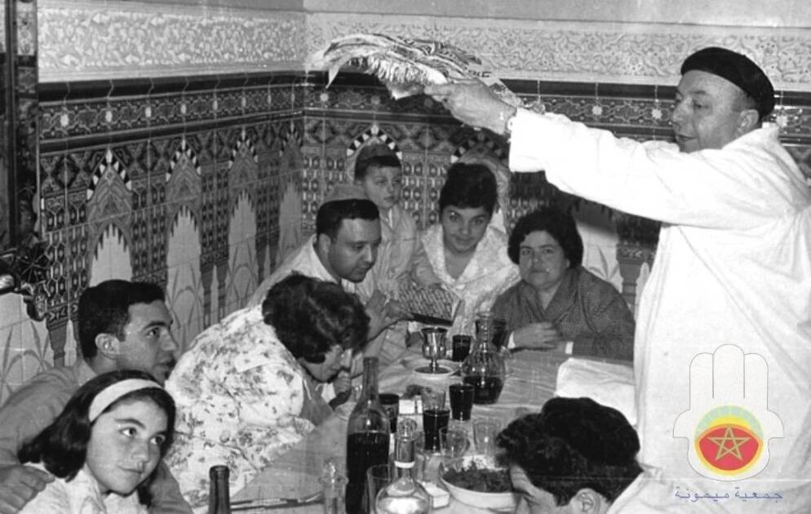  (Passing the seder plate over everyone’s head( |  |  | מַעֲשֶׂה בְּרִבִּי אֱלִיעֶזֶר וְרִבִּי יְהוֹשׁוּעַ וְרִבִּי אֶלְעָזָר בֶּן עֲזַרְיָה וְרִבִּי עֲקִיבָה וְרִבִּי טַרְפוֹן, שֶׁהָיוּ מְסֻבִּין בִּבְנֵי בְרָק; וְהָיוּ מְסַפְּרִין בִּיצִיאַת מִצְרַיִם כָּל אוֹתוֹ הַלַּיְלָה, עַד שֶׁבָּאוּ תַּלְמִידֵיהֶם וְאָמְרוּ לָהֶם:‬  רִבּוֹתֵינוּ, הִגִּיעַ זְמָן קִרְיַת שְׁמַע שֶׁלְּ שַׁחְרִית. | > There is a theory that the rabbis were planning a revolt against Rome. Though there isn’t a lot of evidence to support this, there is still an opportunity to ask: How does the seder prepare you to fight for freedom?
What stories do you have about seders you’ve been part of? Share them here along with these rabbinic stories, or in place of them.  What is your earliest memory of a seder? What’s your funniest seder story?  > During the pandemic, who did you celebrate Passover with? How did you connect? Who was missing from your table? During the endless wars, what are you doing to make this seder different, to remember the lives lost in Israel and in Gaza, in Lebanon or Iran, or in the pogroms against Palestinians in the West Bank? How are you remembering the destruction of Gaza, and how are you hoping for peace? |  |  |  | > The first seder in Egypt was an all night affair where each family was confined to its house. If two families joined together, they had to stay together in one house. During the night of the last plague, to venture out would risk meeting the angel of death.  HYSSOP: If you have hyssop on your seder plate, lift it up. Read:“Take the hyssop and dip it in the blood and daub the lintel and the two doorposts. And you all will not go out, no one, beyond the door of their house until morning. And YHVH will pass through to strike down Egypt, and will see the blood on the lintel…and YHVH will skip over the door and not let the destroyer come in to strike down.” (Exodus 12:22-23)  > Imagine you are at that first seder. How would you feel being confined to your home?
Ben Zoma and the sages have different inter-pretations of why the extra word “all” is part of the verse. |  | Said Elazar ben Azaryah: Here, I am like a seventy-year old, and yet I never merited (to understand why) the going out from Egypt should be spoken of in the nights – until Ben Zoma drashed (explained): As it is said: In order that you will remember the day of your going out from the land of Egypt all the days of your life. (Deut. 16:3) Days of your life – (that would just include) the days. All the days of your life – (that includes even) the nights. And the sages say: Days of your life – (that would just include) this world. All the days – to bring in the days of Mashiach (Messiah). |  | אָמַר לָהֶם רִבִּי אֶלְעָזָר בֶּן עֲזַרְיָה, הֲרֵי אֲנִי כְּבֶן שִׁבְעִים שָׁנָה, וְלֹא זָכִיתִי שֶׁתֵּאָמֵר יְצִיאַת מִצְרַיִם בַּלֵּילוֹת, עַד שֶׁדְּרָשָׁהּ בֶּן זוֹמָא: שֶׁנֶּאֱמָר ״לְמַעַן תִּזְכֹּר אֶת יוֹם צֵאתְךָ מֵאֶרֶץ מִצְרַיִם כֹּל יְמֵי חַיֶּיךָ״ (דברים טז:ג) –״יְמֵי חַיֶּיךָ״, הַיָּמִים; ״כֹּל יְמֵי חַיֶּיךָ״, הַלֵּילוֹת. וַחֲכָמִים אוֹמְרִים ״יְמֵי חַיֶּיךָ״, הָעוֹלָם הַזֶּה; ״כֹּל יְמֵי חַיֶּיךָ״, לְהָבִיא אֶת יְמוֹת הַמָּשִׁיחַ. |  |  | Elazar ben Azaryah is not talking about the seder, but about why we mention leaving Egypt in every evening service: “Every night”. Night time was the beginning of redemption with the first seder, but not the beginning of freedom. What then is the connection between nighttime and the Messiah?
Praise – lift the cup |  | Blessed be the Makom, the Place. Blessed be. Blessed be the One who gave Torah to God’s people Israel. Blessed be.  Hamakom: Because the Holy One is the place that holds the world, but the world cannot hold the Holy One. (Genesis Rabbah 68:9) |  |  | בָּרוּךְ הַמָּקוֹם שֶׁנָּתַן תּוֹרָה לְיִשְׂרָאֵל עַמּוֹ, בָּרוּךְ הוּא.  The seder is one of the few contexts where Hamakom is used frequently as a name of God. |  | When praising God, we lift the cup and cover the matsah. When telling the story, we set the cup down and uncover the broken matsah.
The four children: |  | Concerning four children did the Torah speak: one wise, one wicked, one innocent/whole, and one that doesn’t know to ask. |  |  | כְּנֶגֶד אַרְבָּעָה בָּנִים דִּבְּרָה תּוֹרָה-אֶחָד חָכָם, וְאֶחָד וְאֶחָד רָשָׁע, וְאֶחָד תָּם, וְאֶחָד שְׁאֵינוּ יוֹדֵעַ לִשְׁאֹל. |  | There are four verses in the Torah about retelling the story of leaving Egypt. The rabbis turned them into four types of children.
Chakham/Wise:  In the Torah, the answer to this question is “Avadim Hayinu” – see p.4. |  | A wise one (chakham) – what does that one say? What are the testimonies and statutes and just laws which YHVH our God commanded you-all? (Deut. 6:20) Even so should you be saying to them: according to the laws of the Pesach offering: they don’t add (maftir) after the Pesach any afikoman. |  |  | חָכָם, מַה הוּא אוֹמֵר? ״מָה הָעֵדֹת, וְהַחֻקִּים וְהַמִּשְׁפָּטִים אֲשֶׁר צִוָּה יְהוָה אֱלֹהֵינוּ, אֶתְכֶם?״ (דברים ו:כ) אַף אַתָּה אֱמֹר לוֹ כְּהִלְכַּת | כְּהִלְכוֹת הַפֶּסַח, אֵין מַפְטִירִין אַחַר הַפֶּסַח אֲפִיקוֹמָן.  The “wise one” receives information, not meaning, not revelation. At least the “wicked one” takes a position. |  | The children go up in levels of purity, presence, openness.  The wise one, Chakham, is not having an experience of leaving Egypt. The response to them is similarly disembodied: not “we don’t add”, but “they don’t…”
Rasha/Wicked:  1st use of the phrase Ba`avur zeh:  In the Torah, the Rasha’s question comes just before the tenth plague. |  | A wicked one (rasha) – what does that one say? What is this service/servitude to you-all? (Exod. 12:26)  To you all and not to this one. And just as they have brought themself out of the whole – they have denied the root.  And even you, knock their teeth, and go say to them: “Because of this YHVH acted for me in my going out from Egypt / Ba`avur zeh `asah li Adonai b’tseiti mimitsrayim.” (Exod. 13:8) For me and not for them. If they were there, they were not (would not be) redeemed. |  |  | רָשָׁע, מַה הוּא אוֹמֵר? ״מָה הָעֲבֹדָה הַזֹּאת לָכֶם?״ (שמות יב,כו) ״לָכֶם״, וְלֹא לוֹ. וּלְפִי שֶׁהוֹצִיא אֶת עַצְמוֹ מִן הַכְּלָל וְכָפַר בָּעִיקָר, אַף אַתָּה הַקְהֶה אֶת שִׁנָּיו וֶאֱמֹר לוֹ: ״בַּעֲבוּר זֶה עָשָׂה יְהוָה לִי בְּצֵאתִי מִמִּצְרָיִם״. (שמות יג:ח) –״לִי״, וְלֹא לוֹ; אִלּוּ הָיָה שָׁם, לֹא הָיָה נִגְאָל.  The Torah’s answer is not this verse, but a verse about God skipping over the houses of the Israelites – see “Pesach”, p.14. |  | “Knock his teeth (hak’heh et shinav)” – this is what Adam and Eve experienced when they ate the fruit from the tree of knowing. The Rasha may be irreverent, but they are ready to be engaged, knocked off balance.  This is the first time we mention the verse “Ba`avur zeh”, and it’s used to exclude someone else. The teacher has not learned the lesson.
Tam/Simple: |  | An innocent/simple/whole one (tam) – what does that one say? What’s this? (Exod. 13:14) And you will say unto him: by a strong hand YHVH brought us out from Egypt, from the house of slaves. (Exod. 13:14) |  |  | תָּם, מַה הוּא אוֹמֵר? ״מַה-זֹּאת?״ (שמות יג:יד) ״וְאָמַרְתָּ אֵלָיו-בְּחֹזֶק יָד הוֹצִיאָנוּ יְהוָה מִמִּצְרַיִם, מִבֵּית עֲבָדִים״ (שמות יג:יד) |  | The Tam is present and open, but the one who doesn’t know to ask is the one who is ready for the deepest opening and transformation.
Eino Yode`a /Not Knowing:  2nd Ba`avur zeh: |  | And one who doesn’t know to ask (she’eino yode`a lish’ol)? You open for them, as it is says: And you will tell your child in that day: Because of this YHVH acted for me in my going out from Egypt / Ba`avur zeh… (Exod. 13:8)  “You open.” Open what? Open yourself.  The word for you, “aht”, is the feminine form in Hebrew. So this has also been interpreted, enter/open up to the feminine part of oneself. |  |  | וּשְׁאֵינוּ יוֹדֵעַ לִשְׁאֹל, אַתְּ פְּתַח לוֹ, שֶׁנֶּאֱמָר ״וְהִגַּדְתָּ לְבִנְךָ בַּיּוֹם הַהוּא לֵאמֹר: בַּעֲבוּר זֶה עָשָׂה יְהוָה לִי בְּצֵאתִי מִמִּצְרָיִם״ (שמות יג:ח)  The beginning of redemption is including the other.  To do this also requires including diversity, including the stranger, including the minority, and in our time, including the Palestinian people. |  | This is the second time we mention the verse “Ba`avur zeh”, and the first step in transforming the verse, from using it to exclude others, to using it to include oneself.

3rd Ba`avur zeh:  When should we tell the story?  The 4th Ba’avur zeh appears after Gamliel’s “three things” (p.14). | And you will tell your child… Could it be (that you should start telling the story) from the new moon? Learning says: in that day (Exod. 13:8) – (meaning, only that day when you left Egypt). Could it be from while it is yet day? Learning interprets: Because of this / Ba`avur zeh (Exod. 13:8) – I wouldn’t say “this”, except at the time (this) matsah and maror are set down in front of you (as they are right now). |  | ״וְהִגַּדְתָּ לְבִנְךָ״ ~ יָכוֹל מֵרֹאשׁ הַחֹדֶשׁ? תַּלְמוּד לוֹמַר ״בַּיּוֹם הַהוּא״ (שמות יג:ח)~ אִי ״בַּיּוֹם הַהוּא״, יָכוֹל מִבְּעוֹד יוֹם?‬ תַּלְמוּד לוֹמַר ״בַּעֲבוּר זֶה״ (שמות יג:ח) ~ לֹא אָמַרְתִּי אֵלָא בְּשָׁעָה שֶׁיֵּשׁ מַצָּה וּמָרוֹר מֻנָּחִים לְפָנֶיךָ.  The matsah and maror, symbols of the past, anchor us in the present. |  | The third time we mention the verse “Ba`avur zeh”, it describes engaging fully with the present: what is facing you? Why at this moment? And therefore: who are you, right now? Where are you coming from; where are you going to?
3rd beginning of the story: | From beginning, our ancestors were servants of alien service/ idolatry, and now the Makom (Place) drew us near to service of the One (la`avodato), as it is said: And Yehoshua said to all the people, so said YHVH, Israel’s God – over beyond the River your ancestors were settled from forever, Terach, father of Avraham and father of Nachor, and they served other Gods, and I took your father, Avraham, over beyond the River, and I made him walk through all the land of K’na’an (Canaan), and I multiplied his seed and I gave Yits’hak to him and to Yits’hak I gave Yaakov, and Eisav. And to Eisav I gave Mount Se`ir to inherit it, and Yaakov and his children went down Egypt. (Josh. 24:2-4) |  | מִתְּחִלָּה עוֹבְדֵי עֲבוֹדָה זָרָה הָיוּ אֲבוֹתֵינוּ; וְעַכְשָׁו קֵרְבָנוּ הַמָּקוֹם בָּרוּךְ הוּא לַעֲבוֹדָתוֹ, שֶׁנֶּאֱמָר ״וַיֹּאמֶר יְהוֹשֻׁעַ אֶל כָּל הָעָם, כֹּה אָמַר יְהוָה אֱלֹהֵי יִשְׂרָאֵל, בְּעֵבֶר הַנָּהָר יָשְׁבוּ אֲבוֹתֵיכֶם מֵעוֹלָם, תֶּרַח אֲבִי אַבְרָהָם וַאֲבִי נָחוֹר; וַיַּעַבְדוּ אֱלֹהִים אֲחֵרִים. וָאֶקַּח אֶת אֲבִיכֶם אֶת אַבְרָהָם מֵעֵבֶר הַנָּהָר, וָאוֹלֵךְ אֹתוֹ בְּכָל אֶרֶץ כְּנָעַן; וָאַרְבֶּה אֶת זַרְעוֹ וָאֶתֶּן לוֹ אֶת יִצְחָק. וָאֶתֵּן לְיִצְחָק אֶת יַעֲקֹב וְאֶת עֵשָׂו; וָאֶתֵּן לְעֵשָׂו אֶת הַר שֵׂעִיר לָרֶשֶׁת אוֹתוֹ, וְיַעֲקֹב וּבָנָיו יָרְדוּ מִצְרָיִם״ (יהושוע כד:ב- ד) |  | According to the Talmud, we should start the story from degradation and end it with praise, from g’nut to shevach. But there is a debate about whether degradation means slavery or idol worship. The haggadah includes both beginnings (the 2nd beginning, “We were slaves”, and this one, “Our ancestors were idolaters”).
Praise – lift the cup, cover the matsah | Blessed be the guardian of the promise to Israel. Blessed be, for the Holy One reckoned the end, to do like the One said to Abraham our father at the covenant of the halves, as it is said: And God said to Avram, knowing you must know that your seed will be a stranger/refugee/immigrant (ger) in a land not for them, and they will serve them and they will harm them / impoverish them four hundred years. And also that nation that they serve I will judge, and after that they will go out with great wealth. (Gen. 15:13-14) | 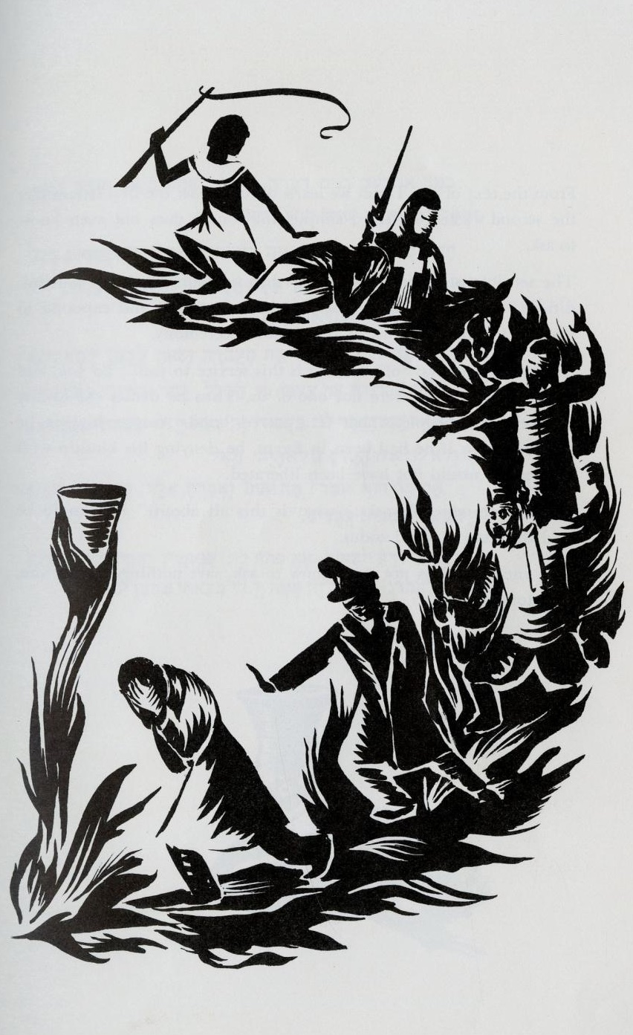V’hi she’amdah, Shalom Aleichem Institute, 1962 |  | בָּרוּךְ שׁוֹמֵר הַבְטָחָתוֹ לְיִשְׂרָאֵל עַמּוֹ, בָּרוּךְ הוּא: שֶׁהַקָּדוֹשׁ בָּרוּךְ הוּא מְחַשֵּׁב אֶת הַקֵּץ, לַעֲשׂוֹת כְּמַה שֶׁאָמַר לְאַבְרָהָם אָבִינוּ בֵּין הַבְּתָרִים, שֶׁנֶּאֱמָר ״וַיֹּאמֶר לְאַבְרָם, יָדֹעַ תֵּדַע כִּי גֵר יִהְיֶה זַרְעֲךָ בְּאֶרֶץ לֹא לָהֶם, וַעֲבָדוּם, וְעִנּוּ אֹתָם אַרְבַּע מֵאוֹת שָׁנָה. וְגַם אֶת הַגּוֹי אֲשֶׁר יַעֲבֹדוּ דָּן אָנֹכִי; וְאַחֲרֵי כֵן יֵצְאוּ בִּרְכֻשׁ גָּדוֹל״ (בראשית טו:יג, יד) | > For all the Torah verses about protecting the stranger, see:  neohasid.org/torah/lovingthestranger/  > “They will go out with great wealth” ~ this means reparations for slavery. What should this teach us about our own time?
V’hi she`amdah  Sometimes people inter-pret “she” to refer to God/ Shekhinah. | And she (the promise) is what stood up for our ancestors and for us, for it wasn’t one alone who stood over us to finish us, but in each and every generation they stand over us to finish us. And the Holy One rescues us from their hand. |  |  | וְהִיא שֶׁעָמְדָה לַאֲבוֹתֵינוּ, וְלָנוּ,‬ שֶׁלֹּא אֶחָד בִּלְבָד עָמַד עָלֵינוּ לְכַלּוֹתֵנוּ, אֵלָא שֶׁבְּכָל דּוֹר וָדוֹר עוֹמְדִים עָלֵינוּ לְכַלּוֹתֵנוּ; וְהַקָּדוֹשׁ בָּרוּךְ הוּא, מַצִּילֵנוּ מִיָּדָם.‬ | > Who “they” are who want to finish us became very tangible for people after October 7th. But how does this passage speak to us now, two years later? What about the forces in Israel and the U.S. that want to finish off liberal democracy?

The next two blocks are not part of the traditional haggadah but will help you understand the haggadah’s structure.
These verses are the basis of the Haggadah. In Temple times, they were recited on Shavuot by farmers when they brought their first-fruit offerings to the priest. | An Aramean who wanders (was) my father, and he went down Egyptward, and he sojourned there in few numbers, and he became there a nation, great, mighty and many. And they did evil to us / made us out to be evil, and they oppressed us, and they put on us heavy service. And we cried out unto YHVH God of our ancestors, and YHVH heard our voice and saw our oppression/ humiliation, and our laboring, and our being squeezed. And YHVH brought us out from Egypt with a strong hand and arm outstretched, with great fear and with signs and with wonders. And brought us unto this place, and gave to us this land, a land dripping milk and honey. And now, here, I have brought the first of the fruit of the earth that YHVH gave to me. (Deut. 26:5-10) | ה אֲרַמִּי אֹבֵד אָבִי, וַיֵּרֶד מִצְרַיְמָה, וַיָּגָר שָׁם בִּמְתֵי מְעָט; וַיְהִי שָׁם לְגוֹי גָּדוֹל עָצוּם וָרָב. ו וַיָּרֵעוּ אֹתָנוּ הַמִּצְרִים וַיְעַנּוּנוּ; וַיִּתְּנוּ עָלֵינוּ עֲבֹדָה קָשָׁה. ז וַנִּצְעַק אֶל יְהוָה אֱלֹהֵי אֲבֹתֵינוּ; וַיִּשְׁמַע יְהוָה אֶת קֹלֵנוּ, וַיַּרְא אֶת עָנְיֵנוּ וְאֶת עֲמָלֵנוּ וְאֶת לַחֲצֵנוּ. ח וַיּוֹצִאֵנוּ יְהוָה מִמִּצְרַיִם, בְּיָד חֲזָקָה וּבִזְרֹעַ נְטוּיָה, וּבְמֹרָא גָּדֹל וּבְאֹתוֹת וּבְמֹפְתִים. ט וַיְבִאֵנוּ אֶל הַמָּקוֹם הַזֶּה; וַיִּתֶּן לָנוּ אֶת הָאָרֶץ הַזֹּאת אֶרֶץ זָבַת חָלָב וּדְבָשׁ. י וְעַתָּה, הִנֵּה הֵבֵאתִי אֶת רֵאשִׁית פְּרִי הָאֲדָמָה אֲשֶׁר נָתַתָּה לִּי יְהוָה. (דברים כו:ה-י) |  |  | This is the most compact narration of Exodus in the Torah. The traditional haggadah does not use the last two verses, which describe coming into the land and reaping her produce. Leaving these verses out recognizes that the current state is not our redemption.
1st verse:  Deut. 26:5 | An Aramean wandering lost (was) my father, and he went down Egyptward, and he sojourned/ dwelled-as-a-stranger there in few numbers, and he became there a nation, great, mighty and many. | אֲרַמִּי אֹבֵד אָבִי, וַיֵּרֶד מִצְרַיְמָה, וַיָּגָר שָׁם בִּמְתֵי מְעָט; וַיְהִי שָׁם, לְגוֹי גָּדוֹל עָצוּם וָרָב. | Now we go line by line and phrase by phrase, explaining the verses of Deut. 26.
1.  4th beginning of the story:  Storytime – Put down the cup and uncover the matsah | Go out and learn what Lavan the Aramean sought to do to Ya`akov our father. For Pharaoh did not decree except against the males, and Lavan sought to uproot all, as it is said: Arami `oved avi/ An Aramean (was) destroying my father / driving my father to become lost…  The fourth beginning of the story is obscured by this midrash, which patently ignores the contextual meaning of the verse: “My father was an Aramean wandering lost…” The verse could originally refer to Abraham or to Jacob. | צֵא וּלְמַד, מַה בִּקֶּשׁ לָבָן הָאֲרַמִּי לַעֲשׂוֹת לְיַעֲקֹב אָבִינוּ, שֶׁפַּרְעֹה הָרָשָׁע לֹא גָזַר אֵלָא עַל הַזְּכָרִים; וְלָבָן בִּקֶּשׁ לַעְקֹר אֶת הַכֹּל, שֶׁנֶּאֱמָר ״אֲרַמִּי אֹבֵד אָבִי״  Why is the haggadah so cagey about finally beginning the story?  Why does our story teach that we are not indigenous to Canaan? |  | Jacob escaped from Esau and left Canaan to go to Padan-Aram where he acquired his wives, children, and wealth from Lavan, then he escaped Lavan, sojourning in Canaan before famine forced him to go down to Egypt. The Jewish people came from Mesopotamia, and formed outside of Canaan, in Padan-Aram, in Egypt and in the desert.
2. | and he went down Egyptward – forced according to the Word / by mouth of the Word. | וַיֵּרֶד מִצְרַיְמָה ~ אָנוּס עַל פִּי הַדִּבּוּר. |  | Forced by the prophecy given to Abraham discussed above.
3. > Do not despise an Egyptian, for you were a stranger/ger in his land. (Deut. 23:7)  > Do the laws that protect strangers countermand the U.S. endangering lives by dismantl-ing USAID? | and he sojourned/ dwelled-as-a-stranger (vayagar) there – teaching that (Jacob) didn’t go down to become sunk/ drowned in Egypt, only to dwell-as-a-stranger there (temporarily), as it’s said: And they said unto Pharaoh, to dwell-as-a-stranger (lagur) in the land have we come, for there is no pasture for the sheep which belong to your servants, for the famine is heavy in the land of K’na`an (Canaan). And now may your servants settle please in the land of Goshen. (Gen. 47:4) | וַיָּגָר שָׁם ~ מְלַמֵּד שֶׁלֹּא יָרַד לְהִשְׁתַּקֵּעַ אֵלָא לָגוּר שָׁם, שֶׁנֶּאֱמָר ״וַיֹּאמְרוּ אֶל פַּרְעֹה לָגוּר בָּאָרֶץ בָּאנוּ, כִּי אֵין מִרְעֶה לַצֹּאן אֲשֶׁר לַעֲבָדֶיךָ, כִּי כָבֵד הָרָעָב בְּאֶרֶץ כְּנָעַן; וְעַתָּה יֵשְׁבוּ נָא עֲבָדֶיךָ, בְּאֶרֶץ גֹּשֶׁן״ (בראשית מז:ד) |  | > “When a stranger/refugee ger sojourns with you in your land you shall not mistreat him. The stranger who sojourns with you shall be for you like a native among you, and you shall love them as yourself, for you were strangers in the land of Egypt. I am YHVH, your God.” (Lev. 19:33-34)
 | >To treat strangers as illegal, as the enemy, is inherently contrary to Torah; it undermines the very ethical foundations of Judaism. This is not a subject in which there are “two Jews, three opinions”. ICE atrocities go against biblical law and morality in every sense.
4. | in few numbers – like what is said: With seventy soul your ancestors went down to Egypt, and now YHVH your God has set you like stars of the sky for multitude. (Deut. 10:22) | בִּמְתֵי מְעָט ~ כְּמוֹ שֶׁנֶּאֱמָר ״בְּשִׁבְעִים נֶפֶשׁ יָרְדוּ אֲבֹתֶיךָ מִצְרָיְמָה; וְעַתָּה שָׂמְךָ יְהוָה אֱלֹהֶיךָ כְּכוֹכְבֵי הַשָּׁמַיִם, לָרֹב״ (דברים י:כב) |  | >The Hebrew tribes in Egypt grew from 70 to 600,000. If the human population grows like that now, there will be no world.

5. | and he became there a nation – teaching that Israel were distinguished/distinct (m’tsuyanim) there. |  | וַיְהִי שָׁם לְגוֹי ~ מְלַמֵּד שֶׁהָיוּ יִשְׂרָאֵל מְצֻיָּנִין שָׁם. | “Distinct” – meaning they didn’t (completely) assimilate.
6. | great, mighty – as it is said: And Israel’s children bore fruit and swarmed and multiplied (v’yirbu) and grew mighty, very very so, and the land filled of them. (Exod. 1:7) |  | גָּדוֹל וְעָצוּם ~ כְּמוֹ שֶׁנֶּאֱמָר ״וּבְנֵי יִשְׂרָאֵל פָּרוּ וַיִּשְׁרְצוּ וַיִּרְבּוּ וַיַּעַצְמוּ בִּמְאֹד מְאֹד; וַתִּמָּלֵא הָאָרֶץ אֹתָם״ (שמות א:ז) | Before this, Joseph enslaved the Egyptians while protecting his own family. See: blogs.timesofisrael.com/learning-from-josephs-mistakes/
7.  (Many liberal haggadot either leave out the second part of this section or don’t translate it.) | and many (rav) – like what is said: Swelling (r’vavah), like the growth of the field, so did I make you, and you increased (tarbi) and grew great and came into such charms – your breasts grew firm and your hair grew, and you were naked and bare. And I passed over you and I saw you squatting in your bloods, and I said to you, in your bloods live! and I said to you, in your bloods live! (Ezek. 16:7, 16:6) |  | וָרָב ~ כְּמוֹ שֶׁנֶּאֱמָר ״רְבָבָה כְּצֶמַח הַשָּׂדֶה נְתַתִּיךְ וַתִּרְבִּי וַתִּגְדְּלִי, וַתָּבֹאִי בַּעֲדִי עֲדָיִים: שָׁדַיִם נָכֹנוּ וּשְׂעָרֵךְ צִמֵּחַ וְאַתְּ עֵרֹם וְעֶרְיָה: וָאֶעֱבֹר עָלַיִךְ וָאֶרְאֵךְ מִתְבּוֹסֶסֶת בְּדָמָיִךְ, וָאֹמַר לָךְ בְּדָמַיִךְ חֲיִי, וָאֹמַר לָךְ בְּדָמַיִךְ חֲיִי״ (יחז׳ טז:ז, ו) | “Your hair grew” means the beginning of puberty. “Squatting in your bloods” means the first menstruation. But midrash says that “bloods” means two: the blood of circumcision, and the blood of the lamb on the doorposts.
 | In Ezekiel 16, God is speaking to Israel. But these verses appear in reverse order in the original text, and the exhortation “in your bloods live” refers to the blood on a newborn baby before it is cleaned. By reversing the order of the verses, the meaning of “bloods” shifts from birth to puberty and menstruation.
2nd verse:  Deut. 26:6 | And the Egyptians eviled us / did evil to us / made us out to be evil, and oppressed/humiliated us, and put on us heavy service. | וַיָּרֵעוּ אֹתָנוּ הַמִּצְרִים, וַיְעַנּוּנוּ; וַיִּתְּנוּ עָלֵינוּ, עֲבֹדָה קָשָׁה. |  |  | “They eviled us” – can mean they did evil to us, or, they saw us as evil.  > Do we do this to enemies? Has Israel done this to African asylum seekers? Bedouin? All Gazans?
1. | And the Egyptians eviled us (v’yarei`u otanu) – as it is said: Come, we will be wise with him lest he increase, and it will be, when war meets, and he will be added on top of our haters, and he will go up from the land. (Exod. 1:10) | וַיָּרֵעוּ אֹתָנוּ הַמִּצְרִים ~ כְּמוֹ שֶׁנֶּאֱמָר ״הָבָה נִתְחַכְּמָה לוֹ,‬ פֶּן יִרְבֶּה וְהָיָה כִּי תִקְרֶאנָה מִלְחָמָה וְנוֹסַף גַּם הוּא עַל שֹׂנְאֵינוּ וְנִלְחַם בָּנוּ, וְעָלָה מִן הָאָרֶץ״ (שמות א:י)
2. | and impoverished/oppressed/humiliated us (v’ya`anunu) – like what is said: and they put over him (the people of Israel) officers of the burdens, in order to oppress him (`anoto) with their burdens, and he built store cities for Pharaoh, Pitom and Ra’amses. (Exod. 1:11) | וַיְעַנּוּנוּ ~ כְּמוֹ שֶׁנֶּאֱמָר ״וַיָּשִׂימוּ עָלָיו שָׂרֵי מִסִּים, לְמַעַן עַנֹּתוֹ בְּסִבְלֹתָם; וַיִּבֶן עָרֵי מִסְכְּנוֹת לְפַרְעֹה,‬ אֶת פִּתֹם וְאֶת רַעַמְסֵס״ (שמות א:יא) |  |  | >You shall not detain/deliver a slave to his lord/master whom he has escaped… With you he will dwell, in your midst, in the place he chooses…where it is good for him. (Deut. 23:16-17)  The Torah assumes that anyone fleeing their overlord is being oppressed and must be given both asylum and freedom of movement.
3. | and they put on us heavy/hard service – as it is said: And Egypt made Israel serve b’farekh, with force. (Exod. 1:13)  “B’farekh” – Hasidic midrash reads this “b’feh rakh”, “with a soft mouth” – deceiving with gentleness. | וַיִּתְּנוּ עָלֵינוּ עֲבֹדָה קָשָׁה ~ כְּמוֹ שֶׁנֶּאֱמָר ״וַיַּעֲבִדוּ מִצְרַיִם אֶת בְּנֵי יִשְׂרָאֵל בְּפָרֶךְ״ (שמות א:יג)
Birdshead Haggadah,  Matsah Baking,  B’khol Dor vaDor | 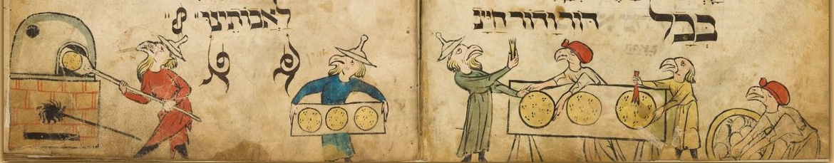
3rd verse:  Deut. 26:7 | And we cried out unto YHVH God of our ancestors, and YHVH heard our voice and saw our oppression, and our laboring, and our being squeezed. | וַנִּצְעַק, אֶל יְהוָה אֱלֹהֵי אֲבֹתֵינוּ; וַיִּשְׁמַע יְהוָה אֶת קֹלֵנוּ, וַיַּרְא אֶת עָנְיֵנוּ וְאֶת עֲמָלֵנוּ וְאֶת לַחֲצֵנוּ | > “You shall not mistreat or oppress/squeeze/t’lacheits a stranger/refugee, for you were strangers in the land of Egypt… If you afflict them, when they cry out to Me, I will surely hear their cry.” (Exod. 22:20, 22)  “One law for tribe and stranger!” (Exod. 12:49, Lev. 24:22, Num. 15:15)  When Israel “squeezes” the other peoples in the land, they violate the essence of the covenant.
1. | And we cried out unto YHVH God of our ancestors – like what is said: And it was in those many days, and the king of Egypt died, and Israel’s children were tortured from the servitude/service (`avodah), and they screamed, and their pleading rose up unto Elohim (God) from (because of) the service/slavery. (Exod. 2:23) | וַנִּצְעַק, אֶל יְהוָה אֱלֹהֵי אֲבֹתֵינוּ ~ כְּמוֹ שֶׁנֶּאֱמָר ״וַיְהִי בַיָּמִים הָרַבִּים הָהֵם, וַיָּמָת מֶלֶךְ מִצְרַיִם, וַיֵּאָנְחוּ בְנֵי-יִשְׂרָאֵל מִן הָעֲבֹדָה וַיִּזְעָקוּ, וַתַּעַל שַׁוְעָתָם אֶל-הָאֱלֹהִים מִן הָעֲבֹדָה״ (שמות ב:כג)
2. | and YHVH heard our voice – like what is said: And Elohim heard their anguish, and Elohim remembered God’s coven-ant with Avraham, with Yits’chak, and with Yaakov. (Exod. 2:24) | וַיִּשְׁמַע יְהוָה אֶת קֹלֵנוּ ~ כְּמוֹ שֶׁנֶּאֱמָר ״וַיִּשְׁמַע אֱלֹהִים אֶת נַאֲקָתָם; וַיִּזְכֹּר אֱלֹהִים אֶת בְּרִיתוֹ, אֶת אַבְרָהָם אֶת יִצְחָק וְאֶת יַעֲקֹב״ (שמות ב:כד)
3. | and saw our oppression/humiliation (`onyeinu) – this is separation of “the way of the land”, like what is said: And Elohim saw Israel’s children, and Elohim knew. (Exod. 2:25)  “Separation” means sexual abstinence; “way of the land” means sexuality. | וַיַּרְא אֶת עָנְיֵנוּ ~ זוֹ פְּרִישׁוּת דֶּרֶךְ אֶרֶץ, כְּמוֹ שֶׁנֶּאֱמָר ״וַיַּרְא אֱלֹהִים אֶת-בְּנֵי יִשְׂרָאֵל; וַיֵּדַע אֱלֹהִים״ (שמות ב:כה) | The men said, why should we make love when our sons will be killed. But the women seduced them, saying, if you act thus, you kill them all.
4. | and our laboring (`amaleinu) – these are the sons (that the women labored to give birth to), like what is said: Any son born, you will throw him Nile-ward, and any daughter you will keep living. (Exod. 1:22) | וְאֶת עֲמָלֵנוּ ~ אֵלּוּ הַבָּנִים, כְּמוֹ שֶׁנֶּאֱמָר ״כָּל-הַבֵּן הַיִּלּוֹד הַיְאֹרָה תַּשְׁלִיכֻהוּ, וְכָל-הַבַּת תְּחַיּוּן״ (שמות א:כב) | Midwives Shifrah and Puah defied Pharaoh by saving the boys. Pharoah responded by commanding the Egyptians to throw boys into the Nile.
5.  “Squeezed” can mean, not allowed to expand their dwell-ings when their families grew. | and our being squeezed (lachatseinu) – this is the pressure (had’chak), like what is said: And also I saw the pressure (halachats) with which Egypt is oppressing them. (Exod. 3:9)  > Zoning is used in East Jerusalem, takeovers and expulsions are happening in Silwan, recognition in withheld from Bedouin villages in the Negev, to “squeeze” the inhabitants.  For a list of threatened villages, see:  btselem.org/settler_violence_updates | וְאֶת לַחֲצֵנוּ ~ זֶה הַדְּחַק, כְּמוֹ שֶׁנֶּאֱמָר ״וְגַם רָאִיתִי אֶת הַלַּחַץ אֲשֶׁר מִצְרַיִם לֹחֲצִים אֹתָם״ (שמות ג:ט)  > This fall, Awdah al-Hathaleen was shot dead by settler Yinon Levi, y’mach sh’mo. Many more have been killed before and since, with impunity. The extremist have been attacking Israelis and internationals providing protective presence, with drones, with iron bars. May the scourge of Jewish terrorist pogroms end. | Palestinians in the West Bank are being squeezed and forced out by extremist settler attacks. Places like Umm al-Kheir are subject to pogroms and more violence than ever before. Villages like Ras ‘Ein al-‘Auja and Wa’ed a-Sha’er have been abandoned.
4th verse:  Deut. 26:8 | And the One brought us out from Egypt with a strong hand and with arm stretched-out, and with great fearsomeness and with signs and with wonders. | וַיּוֹצִאֵנוּ יְהוָה מִמִּצְרַיִם בְּיָד חֲזָקָה וּבִזְרֹעַ נְטוּיָה, וּבְמֹרָא גָּדֹל,‬ וּבְאֹתוֹת וּבְמֹפְתִים. | The next block below continues explaining “our oppression”:
1.  1st description of the plagues: | And the One brought us out from Egypt – not by means of a messenger angel nor by means of a burning angel, nor by means of an emissary, but the Holy One blessed be in glory, as it says: And I will pass over through the land of Egypt in this night, and I will strike down all first-born in the land of Egypt, from human to beast, and I will make judgments against all Egypt’s gods – I am YHVH. (Exod. 12:12) | וַיּוֹצִאֵנוּ יְהוָה מִמִּצְרַיִם ~ לֹא עַל יְדֵי מַלְאָךְ, לֹא עַל יְדֵי שָׂרָף, לֹא עַל יְדֵי שָׁלִיחַ, אֵלָא הַקָּדוֹשׁ בָּרוּךְ הוּא בִּכְבוֹדוֹ: כְּמוֹ שֶׁנֶּאֱמָר ״וְעָבַרְתִּי בְאֶרֶץ מִצְרַיִם בַּלַּיְלָה הַזֶּה, וְהִכֵּיתִי כָל בְּכוֹר בְּאֶרֶץ מִצְרַיִם מֵאָדָם וְעַד בְּהֵמָה; וּבְכָל אֱלֹהֵי מִצְרַיִם אֶעֱשֶׂה שְׁפָטִים, אֲנִי יְהוָה״ (שמות יב:יב) | > You shall not oppress a hired worker who is poor and needy from your brothers or from your stranger that is in your land… You shall not distort the justice due a stranger… (Deut. 24:14, 17)

 | 1. (cont’d) |  |  |  | And I will pass over through the land of Egypt in this night – I and not a messenger/angel.  and I will strike down all first-born in the land of Egypt – I and not a burning angel.  and I will make judgments against all the Egypt’s gods – I and not an emissary.  I am YHVH – I am the One, and no other. |  |  | וְעָבַרְתִּי בְאֶרֶץ מִצְרַיִם בַּלַּיְלָה הַזֶּה.‬ אֲנִי וְלֹא מַלְאָךְ  וְהִכֵּיתִי כָל בְּכוֹר בְּאֶרֶץ מִצְרַים. אֲנִי וְלֹא שָׂרָף  וּבְכָל אֱלֹהֵי מִצְרַיִם אֶעֱשֶׂה שְׁפָטִים. אֲנִי וְלֹא הַשָּׁלִיחַ. אֲנִי ה׳ אֲנִי הוּא וְלֹא אַחֵר. |  | > You shall remember that you were a slave in Egypt, and that YHVH your God redeemed you from there. (Deut. 24: 18)  > We honor the God who liberates slaves every time we care for the stranger or the poor.
 | 2.  2nd description of the plagues: |  |  |  | with a strong hand – this is the pestilence (dever), like what is said: Here, the hand of YHVH is-coming-to-be/ hoyah/ HVYH upon your herd in the field, on the horses, on the donkeys, on the camels, on the cattle and on the flocks, a very heavy pestilence. (Exod. 9:3) |  |  | בְּיָד חֲזָקָה ~ זֶה הַדֶּבֶר, כְּמוֹ שֶׁנֶּאֱמָר ״הִנֵּה יַד יְהוָה הוֹיָה, בְּמִקְנְךָ אֲשֶׁר בַּשָּׂדֶה, בַּסּוּסִים בַּחֲמֹרִים בַּגְּמַלִּים בַּבָּקָר וּבַצֹּאן,-דֶּבֶר כָּבֵד מְאֹד״ (שמות ט:ג) |  | > The oppression committed by humans against each other always comes to harm the other creatures as well.  > War strikes down innocent and guilty, and destroys the land.
 | 3. |  |  |  | and with arm stretched-out – this is the sword, like what is said: And the sword drawn in God’s hand stretched out over Jerusalem. (1Chr. 21:16) |  |  | וּבִזְרֹעַ נְטוּיָה ~ זוֹ הַחֶרֶב, כְּמוֹ שֶׁנֶּאֱמָר ״וְחַרְבּוֹ שְׁלוּפָה בְּיָדוֹ נְטוּיָה עַל יְרוּשָׁלִָם״ (דברי הימים א כא:טז) |  | This verse in context describes the plague that strikes Israel after David “sins” by counting the people.
 | 4. We are living in a time of great fear. Taking time during your seder to explore those feelings can enable people with different politics to hear each other. |  |  |  | and with great fearsomeness – this is the revelation of the Shekhinah/God’s presence, like what is said: Or did Elohim strive/try (make a miracle), to come to take a nation from within a nation, with trials and with signs and with wonders, and with a strong hand and arm stretched-out, and with great fearsomeness, according to all that YHVH your God did for you in Egypt, before your eyes? (Deut. 4:34) |  |  | וּבְמֹרָא גָּדֹל ~ זֶה גִּלּוּי שְׁכִינָה, כְּמוֹ שֶׁנֶּאֱמָר ״אוֹ הֲנִסָּה אֱלֹהִים לָבוֹא לָקַחַת לוֹ גוֹי מִקֶּרֶב גּוֹי בְּמַסֹּת בְּאֹתֹת וּבְמוֹפְתִים וּבְמִלְחָמָה,‬ וּבְיָד חֲזָקָה וּבִזְרוֹעַ נְטוּיָה, וּבְמוֹרָאִים גְּדֹלִים: כְּכֹל אֲשֶׁר עָשָׂה לָכֶם יְהוָה אֱלֹהֵיכֶם בְּמִצְרַיִם לְעֵינֶיךָ״ (דברים ד:לד) |  | The revelation of Shekhinah, the feminine aspect of God, is described here, while below (p.14) the haggadah describes the revelation of the Holy One. How might these be different?
 | 5. |  |  |  | and with signs – this is the staff, as it is said: And this staff you will take in your hand, that you will do with it the signs. (Exod. 4:17) |  |  | וּבְאֹתוֹת ~ זֶה הַמַּטֶּה, שֶׁנֶּאֱמָר ״וְאֶת-הַמַּטֶּה הַזֶּה תִּקַּח בְּיָדֶךָ אֲשֶׁר תַּעֲשֶׂה-בּוֹ אֶת-הָאֹתֹת״ (שמות ד:יז) |  | “You will take” refers to Moshe. This is the only reference to Moshe in the traditional haggadah.
 | 6. |  |  |  | and with wonders – this is the blood, like what is said: And I will put my wonders in the skies and in the land, blood, and fire, and pillars of smoke. (Joel 3:3) |  |  | וּבְמֹפְתִים ~ זֶה הַדָּם, כְּמוֹ שֶׁנֶּאֱמָר ״וְנָתַתִּי מוֹפְתִים בַּשָּׁמַיִם וּבָאָרֶץ: דָּם וָאֵשׁ וְתִימְרוֹת עָשָׁן״ (יואל ג:ג) |  | This verse is actually about the “end of days”, even though it is reminiscent of the plagues.
 | 7.  3rd description of the plagues:  4th description of the plagues: |  |  |  | Another word: and with a strong hand – two, and with an arm stretched-out – two, and with great fearsomeness – two, and with signs – two, and with wonders – two. These are the ten blows (plagues) that the Holy One brought on the Egyptians in Egypt, and they were:  Blood – Dam, Frog – Ts’fardei`a, Lice – Kinim,  Swarm – `Arov, Pestilence – Dever, Boils – Sh^{e}chin,  Hail – Barad, Locust – Arbeh, Darkness – Choshekh,  Striking-down the Firstborn – Makat B^{e}khorot. |  |  | דָּבָר אַחֵר: בְּיָד חֲזָקָה ~ שְׁתַּיִם, וּבִזְרֹעַ נְטוּיָה ~ שְׁתַּיִם, וּבְמֹרָא גָּדֹל ~ שְׁתַּיִם, וּבְאֹתוֹת ~ שְׁתַּיִם, וּבְמֹפְתִים ~ שְׁתַּיִם. אֵלּוּ עֶשֶׂר מַכּוֹת שֶׁהֵבִיא הַקָּדוֹשׁ בָּרוּךְ הוּא עַל הַמִּצְרִיִּים בְּמִצְרַיִם וְאֵלּוּ הֶן  דָּם, צְפַרְדֵּעַ, כִּנִּים, עָרוֹב, דֶּבֶר, שְׁחִין, בָּרָד, אַרְבֶּה, חֹשֶׁךְ, מַכַּת בְּכוֹרוֹת.  `Arov has been interpreted as swarms of flies and as a “mixture” of wild beasts. Since the word `arov is only used in relation to this plague, its original meaning is uncertain. |  | The leader in a Syrian seder will pour out some wine for each plague into a bowl. Almost the whole rest of the cup is poured out at the intonation of Makat b’khorot.  Traditionally this bowl of plagues was rushed to the toilet and flushed away. I save it and pour it out on the earth at Sh’fokh Chamat’kha below.
 |  | 8. A mnemonic: |  |  | R’ Yehudah would make a word-sign/ siman (acronym) out of them: Datsakh, Adash, B’achav. | רִבִּי יְהוּדָה הָיָה נוֹתֵן בָּהֶם סִימָן: דְּצַ״ךְ עֲדַּ״שׁ בְּאַחַ״ב. |  |  |  |  | This mnemonic is to help us remember the order of plagues.
 |  | 9.  Multiplying the plagues: |  |  | R’ Yosi the Galilean says: From where would you say (interpret) that the Egyptians in Egypt were struck with ten blows/strikes/plagues, and on the sea they were struck with fifty blows? In Egypt what does it say? And the sorcerers said unto Pharaoh: It is the finger of God. And on the sea what does it say? And Israel saw the great hand which YHVH acted with (against) Egypt, and the people feared YHVH, and they believed in YHVH and in Moshe God’s servant. (Exod. 14:11) How many strikes with a finger? Ten strikes. From now say: In Egypt they were struck with ten blows, and on the sea they were struck with fifty blows. | רַבִּי יוֹסֵי הַגְּלִילִי אוֹמֵר: מִנַּיִן אַתָּה אוֹמֵר שֶׁלָּקוּ הַמִּצְרִים בְּמִצְרַיִם עֶשֶׂר מַכּוֹת וְעַל הַיָּם לָקוּ חֲמִשִּׁים מַכּוֹת? בְּמִצְרַיִם מַה הוּא אוֹמֵר? וַיֹּאמְרוּ הַחַרְטֻמִּם אֶל פַּרְעֹה: אֶצְבַּע אֱלֹהִים הִוא, וְעַל הַיָּם מָה הוּא אוֹמֵר? וַיַּרְא יִשְׂרָאֵל אֶת-הַיָּד הַגְּדֹלָה אֲשֶׁר עָשָׂה ה׳ בְּמִצְרַיִם, וַיִּירְאוּ הָעָם אֶת-ה׳, וַיַּאֲמִינוּ בַּיי וּבְמשֶׁה עַבְדוֹ. כַּמָה לָקוּ בְאֶצְבַּע? עֶשֶׂר מַכּוֹת. אֱמוֹר מֵעַתָּה: בְּמִצְרַים לָקוּ עֶשֶׂר מַכּוֹת וְעַל הַיָּם לָקוּ חֲמִשִּׁים מַכּוֹת. |  |  |  |  | These sections are not found in the Rambam’s version of the haggadah. Many seders skip these two sections, from “R’ Yosi the Galilean” through “two hundred and fifty blows”. The following midrash can be used as an alternative reading:  Another midrash about the sea:  According to R’ Yochanan, after Israel crossed the sea and it closed on the Egyptians and their horses, “the ministering angels sought to chant a song. Said the Holy One: The work of My hands – they are drowning in the sea! And you chant a song?” Therefore, it says “this one did not come near to that one” (Exod. 14:20), hinting that God would not let the angels join together to sing. (Talmud Megilah 10b)  R’ Yochanan’s midrash takes Exod. 14:20 out of context. In the story, “this one did not come near to that one” means Israel and Egypt did not come near each other the whole night. Some of our most powerful lessons come from inventing new contexts for old words.
 |  | 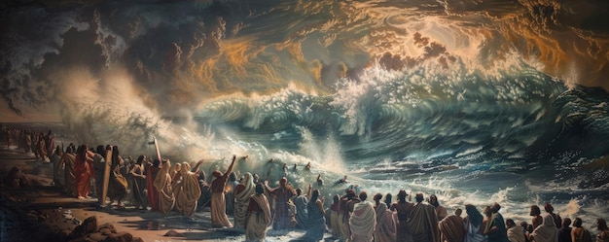
 |  | 10.  Re-multiplying the plagues:  Why do the rabbis perform these mathematical tricks with the plagues? Are they trying to outdo each other? To convince themselves of God’s power? |  |  | R Eli`ezer says: From where would you say (interpret) that for every blow which the Holy One brought on the Egyptians in Egypt there were four blows? For it is said: Against them were sent God’s burning anger, passion and fury and trouble, from the emissaries/angels of evils. (Psalms 78:49) God’s burning anger – one, Passion – two, and fury – three, and trouble – four. From now say: In Egypt they were struck with forty blows, and on the sea they were struck with two hundred blows.  R’ Akiva says: From where would you say that for every blow which the Holy One brought on the Egyptians in Egypt there were five blows? For it is said: And against them were sent God’s burning anger, and passion and fury and trouble, from the emissaries of evils. God’s burning anger – one, passion – two, and fury – three, and trouble – four, from the emissaries of evils – five. From now say: In Egypt they were struck with fifty blows, and on the sea they were struck with two hundred and fifty blows. | רַבִּי אֱלִיעֶזֲר אוֹמֵר: מִנַּיִן שֶׁכָּל-מַכָּה וּמַכָּה שֶׁהֵבִיא הַקָּדוֹשׁ בָּרוּךְ הוּא עַל הַמִּצְרִים בְּמִצְרַיִם הָיְתָה שֶׁל אַרְבַּע מַכּוֹת? שֶׁנֶּאֱמַר: יְשַׁלַּח-בָּם חֲרוֹן אַפּוֹ, עֶבְרָה וָזַעַם וְצָרָה, מִשְׁלַחַת מַלְאֲכֵי רָעִים. (תהילים עח:מט) עֶבְרָה ~ אַחַת, וָזַעַם ~ שְׁתַּיִם, וְצָרָה ~ שָׁלשׁ, מִשְׁלַחַת מַלְאֲכֵי רָעִים ~ אַרְבַּע. אֱמוֹר מֵעַתָּה: בְּמִצְרַיִם לָקוּ אַרְבָּעִים מַכּוֹת וְעַל הַיָּם לָקוּ מָאתַיִם מַכּוֹת.  רַבִּי עֲקִיבָא אוֹמֵר: מִנַּיִן שֶׁכָּל-מַכָּה וּמַכָּה שֶהֵבִיא הַקָּדוֹשׁ בָּרוּךְ הוּא עַל הַמִּצְרִים בְּמִצְרַיִם הָיְתָה שֶׁל חָמֵשׁ מַכּוֹת? שֶׁנֶּאֱמַר: יְִשַׁלַּח-בָּם חֲרוֹן אַפּוֹ, עֶבְרָה וָזַעַם וְצַרָה, מִשְׁלַחַת מַלְאֲכֵי רָעִים. חֲרוֹן אַפּוֹ- אַחַת, עֶבְרָה ~ שְׁתָּיִם, וָזַעַם ~ שָׁלוֹשׁ, וְצָרָה ~ אַרְבַּע, מִשְׁלַחַת מַלְאֲכֵי רָעִים ~ חָמֵשׁ. אֱמוֹר מֵעַתָּה: בְּמִצְרַיִם לָקוּ חֲמִשִּׁים מַכּות וְעַל הַיָּם לָקוּ חֲמִשִּׁים וּמָאתַיִם מַכּוֹת.
Dayeinu! l |  |  | How many good steps by the Makom (Place) raised us up!  If the One brought us out from Egypt, and did not do judgments with them - that’s enough for us! Dayeinu!  If the One did judgments with them, and did not do so with their gods – Dayeinu!  If the One did so with their gods, and did not kill their firstborn – Dayeinu!  If the One killed their firstborn, and did not give us their wealth/mamon – Dayeinu!  If the One gave us their wealth, and did not split the sea for us – Dayeinu!  If the One split the sea for us, and did not make us pass through on dry land – Dayeinu!  If the One made us pass through on dry land, and did not drown our oppressors in its midst – Dayeinu!  If the One drowned our oppressors in its midst, and did not stop our needing in the desert forty years – Dayeinu!  If the One stopped our needing in the wilderness/desert forty years, and did not feed us manna – Dayeinu!  If the One fed us manna, and did not give us Shabbat – Dayeinu!  If the One gave us Shabbat, and did not bring us near before Mt. Sinai – Dayeinu!  If the One brought us near before Mt. Sinai, and did not give us the Torah – Dayeinu!  If the One gave us the Torah, and did not make us enter the land of Israel – Dayeinu!  If the One made us enter the land of Israel, and did not build for us the chosen House (the Temple) – Dayeinu!  > What things do you need to ask for in this time of torment and torture? To which of the steps of “Dayeinu” could you say it would be enough? |  |  |  | כַּמָה מַעֲלוֹת טוֹבוֹת לַמָּקוֹם עָלֵינוּ!  אִלּוּ הוֹצִיאָנוּ מִמִצְרַיִם וְלֹא עָשָׂה בָהֶם שְׁפָטִים, דַּיֵּנוּ.  אִלּוּ עָשָׂה בָהֶם שְׁפָטִים, וְלֹא עָשָׂה בֵאלֹהֵיהֶם, דַּיֵּנוּ.  אִלּוּ עָשָׂה בֵאלֹהֵיהֶם, וְלֹא הָרַג אֶת-בְּכוֹרֵיהֶם, דַּיֵּנוּ.  אִלּוּ הָרַג אֶת-בְּכוֹרֵיהֶם וְלֹא נָתַן לָנוּ אֶת-מָמוֹנָם, דַּיֵּנוּ.  אִלּוּ נָתַן לָנוּ אֶת-מָמוֹנָם וְלֹא קָרַע לָנוּ אֶת-הַיָּם, דַּיֵּנוּ.  אִלּוּ קָרַע לָנוּ אֶת-הַיָּם וְלֹא הֶעֱבִירָנוּ בְּתוֹכוֹ בֶּחָרָבָה, דַּיֵּנוּ.  אִלּוּ הֶעֱבִירָנוּ בְּתוֹכוֹ בֶּחָרָבָה וְלֹא שִׁקַּע צָרֵנוּ בְּתוֹכוֹ דַּיֵּנוּ.  אִלּוּ שִׁקַּע צָרֵנוּ בְּתוֹכוֹ וְלֹא סִפֵּק צָרְכֵּנוּ בַּמִדְבָּר אַרְבָּעִים שָׁנָה די׳  אִלּוּ סִפֵּק צָרְכֵּנוּ בְּמִדְבָּר אַרְבָּעִים שָׁנָה וְלֹא הֶאֱכִילָנוּ אֶת-הַמָּן די׳  אִלּוּ הֶאֱכִילָנוּ אֶת-הַמָּן וְלֹא נָתַן לָנוּ אֶת-הַשַׁבָּת, דַּיֵּנוּ.  אִלּוּ נָתַן לָנוּ אֶת-הַשַׁבָּת, וְלֹא קֵרְבָנוּ לִפְנֵי הַר סִינַי, דַּיֵּנוּ.  אִלּוּ קֵרְבָנוּ לִפְנֵי הַר סִינַי, וְלא נַתַן לָנוּ אֶת-הַתּוֹרָה. דַּיֵּנוּ.  אִלּוּ נַתַן לָנוּ אֶת-הַתּוֹרָה וְלֹא הִכְנִיסָנוּ לְאֶרֶץ יִשְׂרָאֵל, דַּיֵּנוּ.  אִלּוּ הִכְנִיסָנוּ לְאֶרֶץ יִשְׂרָאֵל וְלֹא בָנָה לָנוּ אֶת-בֵּית הַבְּחִירָה דַּיֵּנוּ. |  |  |  |  | Would any of these really be enough? Would we say, having come to the sea but not being able to cross, at least we witnessed the revelation of God’s power? Or is it simply that we should recognize the miracle at each step?  It is Persian and Iraqi custom to hit each other on the head with scallions during Dayeinu. Some communities do a similar playlet with scallions at Avadim Hayyinu (p.5) or `Avodah Kashah (p.9).  Now is the right time to sing “Avadim hayyinu, atah B’nai Chorin” – We were slaves, now we are freed people.  >It will not be enough if protests pause the putsch to undo Israel’s independent judiciary, or if in the U.S. they force the administrat’n to respect due process. It will not be enough to protest the next war. It will not be enough to block settler violence by protective presence, or to force Israel’s government to stop extremist settler violence and pogroms. In the West Bank.
 |  |  | Beyond each one, so much more so all of them – goodness doubled and redoubled by the Makom (Place) for us…  For the One brought us out from Egypt, and did judgments with them and did with their gods, and killed their firstborn and gave us their wealth, and split the sea for us and made us pass through on dry land, and drowned our oppressors in its midst, and stopped our needing in the wilderness/desert forty years and fed us manna, and gave us Shabbat, and brought us near before Mt. Sinai and gave us the Torah, and made us enter the land of Israel and built for us the chosen House (the Temple) to atone for our sins. |  |  |  | עַל אַחַת כַּמָה וְכַּמָה, טוֹבָה כְפוּלָה וּמְכֻפֶּלֶת לַמָּקוֹם עָלֵינוּ:  שֶׁהוֹצִיאָנוּ מִמִּצְרַיִם, וְעָשָׂה בָהֶם שְׁפָטִים, וְעָשָׂה בֵאלֹהֵיהֶם, וְהָרַג אֶת-בְּכוֹרֵיהֶם, וְנָתַן לָנוּ אֶת-מָמוֹנָם, וְקָרַע לָנוּ אֶת-הַיָּם, וְהֶעֱבִירָנוּ בְּתוֹכוֹ בֶּחָרָבָה, וְשִׁקַּע צָרֵנוּ בְּתוֹכוֹ, וְסִפֵּק צָרְכֵּנוּ בַּמִדְבָּר אַרְבָּעִים שָׁנָה, וְהֶאֱכִילָנוּ אֶת-הַמָּן, וְנָתַן לָנוּ אֶת-הַשַּׁבָּת, וְקֵרְבָנוּ לִפְנֵי הַר סִינַי, וְנַתָן לָנוּ אֶת-הַתּוֹרָה, וְהִכְנִיסָנוּ לְאֶרֶץ יִשְׂרָאֵל, וּבָנָה לָנוּ אֶת-בֵּית הַבְּחִירָה לְכַפֵּר עַל-כָּל-עֲוֹנוֹתֵינוּ.
The three things that must be explained: |  |  |  | Rabban Gamliel would say: Anyone who did not say these three things on Pesach has not gone out from the grip of their obligation: Pesach, Matsah, and Maror/bitters. |  |  | רַבַּן גַּמְלִיאֵל אוֹמֵר, כָּל שֶׁלֹּא אָמַר שְׁלוֹשָׁה דְּבָרִים אֵלּוּ בַּפֶּסַח, לֹא יָצָא יְדֵי חוֹבָתוֹ: פֶּסַח, מַצָּה, וּמָרוֹר. |  | Pointing out these three things is enough to fulfill the mitsvah of the seder according to Rabban Gamliel.
1) Pesach  Vegetarians may use a roasted beet. The shankbone or beet is not lifted up so as not to confuse it with the actual sacrifice. |  |  |  | Pesach that our ancestors were eating in the time when the House of the Sanctuary (Temple) was standing, is because of what? Because the Holy One skipped over the houses of our ancestors in Egypt, as it is said: And you all will say: it is a sacrifice of Pesach for YHVH, who skipped (pasach-ed) over the houses of the children of Israel in Egypt in God’s plaguing Egypt, and our houses the One rescued. And the people bowed and prostrated. (Exod. 12:27) |  |  | פֶּסַח שֶׁהָיוּ אֲבוֹתֵינוּ אוֹכְלִין בִּזְמָן שֶׁבֵּית הַמִּקְדָּשׁ קַיָּם, עַל שׁוּם מָה?-עַל שׁוּם שֶׁפָּסַח הַמָּקוֹם עַל בָּתֵּי אֲבוֹתֵינוּ בְּמִצְרַיִם, שֶׁנֶּאֱמָר ״וַאֲמַרְתֶּם זֶבַח פֶּסַח הוּא לַיהוָה אֲשֶׁר פָּסַח עַל בָּתֵּי בְנֵי יִשְׂרָאֵל בְּמִצְרַיִם, בְּנָגְפּוֹ אֶת מִצְרַיִם, וְאֶת בָּתֵּינוּ הִצִּיל; וַיִּקֹּד הָעָם וַיִּשְׁתַּחֲווּ״ (שמות יב:כז) |  | The verse “And you all will say” comes before the last plague, though some say it came when the people first learned God was going to redeem them. If so, they were still innocent about the plagues and terror they would soon witness.
2) Matsah:  2nd explanation of matsah ~  Point to the broken matsah |  |  |  | This matsah that we are eating, is because of what? Because their dough did not stop to rise/become chamets beforethere was revealed over them the Ruler over the kings of kings, the Holy One blessed be, and then redeemed them immediately, as it’s said: And they baked the dough which they brought out from Egypt, cakes of matsot, for it didn’t rise/ become chamets, for they were driven from Egypt, and they couldn’t linger/hesitate, and also provision/hunt they didn’t make for themselves. (Exod. 12:39) |  |  | מַצָּה זוֹ שֶׁאֲנַחְנוּ אוֹכְלִין, עַל שׁוּם מָה?-עַל שׁוּם שֶׁלֹּא הִסְפִּיק בְּצֵקָם שֶׁלַּאֲבוֹתֵינוּ לְהַחְמִיץ עַד שֶׁנִּגְלָה עֲלֵיהֶם מֶלֶךְ מַלְכֵי הַמְּלָכִים הַקָּדוֹשׁ בָּרוּךְ הוּא וּגְאָלָם מִיָּד, שֶׁנֶּאֱמָר ״וַיֹּאפוּ אֶת הַבָּצֵק אֲשֶׁר הוֹצִיאוּ מִמִּצְרַיִם עֻגֹת מַצּוֹת כִּי לֹא חָמֵץ: כִּי גֹרְשׁוּ מִמִּצְרַיִם וְלֹא יָכְלוּ לְהִתְמַהְמֵהַּ, וְגַם-צֵדָה לֹא-עָשׂוּ לָהֶם״ (שמות יב:לט) |  | This is the matsah of leaving Egypt. It is the first transformation of matsah from symbol of slavery to freedom.  “The Holy One was revealed” – earlier the haggadah points to “the revelation of the Shekhinah”. In Kabbalah, the Holy One is masculine and Shekhinah feminine. The two dimensions must come together to bring liberation.
3) Maror:  Lift up the maror  Explain other symbols on your seder plate (egg, shankbone, etc.)  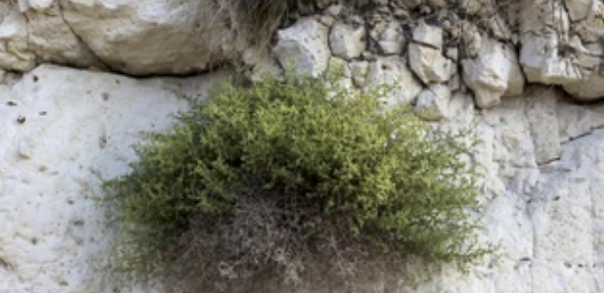 |  |  |  | This maror that we are eating, is because of what? Because the Egyptians made bitter the lives of our ancestors in Egypt, as it is said: And they made bitter their lives with stiff/hard servitude/service (`avodah kashah), with mortar and bricks and with all `avodah in the field, all their` avodah with which they served them b’farekh, with force. (Exod. 1:14) |  |  | מָרוֹר זֶה שֶׁאֲנַחְנוּ אוֹכְלִין, עַל שׁוּם מָה?-עַל שׁוּם שֶׁמֵּרְרוּ הַמִּצְרִיִּים אֶת חַיֵּי אֲבוֹתֵינוּ בְּמִצְרַיִם, שֶׁנֶּאֱמָר ״וַיְמָרְרוּ אֶת חַיֵּיהֶם בַּעֲבֹדָה קָשָׁה, בְּחֹמֶר וּבִלְבֵנִים וּבְכָל-עֲבֹדָה בַּשָּׂדֶה,‬ אֵת כָּל עֲבֹדָתָם, אֲשֶׁר עָבְדוּ בָהֶם בְּפָרֶךְ״ (שמות א:יד) |  | Some say charoset represents the mortar or the mud for the bricks, but see other explanations below under Maror (p.16). The symbolism of the charoset is never explained in the text of the haggadah. Why might that be?  On answer may be that charoset represents the parts of slavery, of trauma, that we are not yet ready to put “in order” – see page 16, bottom.
 |  |  |  | For hyssop: Eizov zo al shum mah? This is because of the blood painted with hyssop onto the doorpost that saved the Israelites in Egypt from the the plague of the firstborn, and because we share this symbol with the Palestinian people, for whom it represents being steadfast. We imagine a time when none of our children will die because of terror or war, and the whole land will be filled with peace and justice.
4th Ba`avur zeh:  The climax of the seder!  This section completes the transformation of the verse “Ba`avur zeh”. |  |  |  | In each and every generation, a person is obligated to see (to show) themself as if they went out from Egypt, as it is said: And you will tell to your child in that day, Because of this YHVH acted for me in my going out from Egypt / Ba`avur zeh `asah li YHVH b’tseiti mimitsrayim. (Exod. 12:26) For not only our ancestors alone did the Holy One redeem, blessed be. Rather, even us the One redeemed, as it is said: And us God brought from there, in order to bring us, to give to us the land that was sworn to our ancestors. (Deut. 6:23) |  |  | וּבְכָל דּוֹר וָדוֹר, חַיָּב אָדָם לִרְאוֹת (לְהַרְאוֹת) אֶת עַצְמוֹ כְּאִלּוּ הוּא יָצָא מִמִּצְרַיִם, שֶׁנֶּאֱמָר ״וְהִגַּדְתָּ לְבִנְךָ בַּיּוֹם הַהוּא לֵאמֹר: ״בַּעֲבוּר זֶה עָשָׂה יְהוָה לִי בְּצֵאתִי מִמִּצְרָיִם״ (שמות יג:ח), שֶׁלֹּא אֶת אֲבוֹתֵינוּ בִּלְבָד גָּאַל, אֵלָא אַף אוֹתָנוּ גָּאַל, שֶׁנֶּאֱמָר ״וְאוֹתָנוּ הוֹצִיא מִשָּׁם לְמַעַן הָבִיא אֹתָנוּ לָתֶת לָנוּ אֶת הָאָרֶץ אֲשֶׁר נִשְׁבַּע לַאֲבֹתֵינוּ״ (דברים ו:כג) |  | Hopefully when we get to this point of the seder we understand the lesson: We cannot include ourselves in the story by excluding anyone. Excluding others only happens when we are telling a story about others, about the past. Here, as we are called to be fully present, and we invite our own soul to become part of this stoty, our story.

Lift the cup! | Therefore we are compelled to give thanks, to praise, to extol, to beautify, to exalt, to adorn, to bless, to raise up, and to be jubilant to the One who did for our ancestors and for us all these miracles, who brought us out from slavery/ `avdut to freedom/cherut, from agony to joy, from mourning to holiday, from thick darkness to great light, from servitude to redemption. And (so) we will day before the One a new song, Hal’luyah! Praise Yah! | לְפִיכָּךְ אָנוּ חַיָּבִים לְהוֹדוֹת לְהַלֵּל לְשַׁבֵּחַ לְפָאֶר לְרוֹמַם לְגַדֶּל וּלְהַדֶּר וּלְנַצַּח וּלְבָרֶךְ לְמִי שֶׁעָשָׂה לָנוּ וְלַאֲבוֹתֵינוּ אֵת כָּל הַנִּסִּים הָאֵלּוּ, וְהוֹצִיאָנוּ מֵעַבְדוּת לְחֵרוּת, וּמִשִּׁעְבּוּד לִגְאֻלָּה, וּמִיָּגוֹן לְשִׂמְחָה, וּמֵאֵבֶל לְיוֹם טוֹב, וּמֵאֲפֵלָה לְאוֹר גָּדוֹל; וְנֹאמַר לְפָנָיו, הַלְלוּיָהּ! |  |  | Now that we have made ourselves part of the story, we can know truly what our obligation is, and what it means to give thanks.
Here we recite the first two Psalms of Hallel to conclude the telling:  Psalm 113  Translations in the right column: | Hal’luyah! Hal’lu `avdei YHVH/Adonai,  hal’lu et sheim Adonai.  Y’hi sheim Adonai m’vorakh mei`atah v`ad `olam.  Mimizrach shemesh `ad m’vo’o m’hulal sheim Adonai.  Ram `al kol goyim Adonai, `al hashamayim k’vodo.  Mi kAdonai Eloheinu hamagbihi lashevet.  Hamashpili lir’ot bashamayim uva’arets?  M’kimi mei`afar dal, mei’ashpot yarim evyon,  l’hoshivi `im n’divim, `im n’divei `amo.  Moshivi `akeret habayit, eim habanim s’meikhah. Hal’luyah!  >God’s majesty is found equally in God’s own exaltedness and in God’s exaltation of those who have been brought low. | הַלְלוּיָהּ הַלְלוּ עַבְדֵי יְהוָה,  הַלְלוּ אֶת-שֵׁם יְהוָה.  יְהִי שֵׁם ה׳ מְבֹרָךְ מֵעַתָּה וְעַד עוֹלָם.  מִמִּזְרַח שֶׁמֶשׁ עַד מְבוֹאוֹ מְהֻלָּל שֵׁם יְהוָה.  רָם עַל-כָּל-גּוֹיִם יְהוָה, עַל הַשָּׁמַיִם כְּבוֹדוֹ.  מִי כַּיי אֱלֹהֵינוּ הַמַּגְבִּיהִי לָשָׁבֶת,  הַמַּשְׁפִּילִי לִרְאוֹת בַּשָּׁמַיִם וּבָאָרֶץ?  מְקִימִי מֵעָפָר דָּל, מֵאַשְׁפֹּת יָרִים אֶבְיוֹן,  לְהוֹשִׁיבִי עִם-נְדִיבִים, עִם נְדִיבֵי עַמּוֹ.  מוֹשִׁיבִי עֲקֶרֶת הַבַּיִת, אֵם הַבָּנִים שְׂמֵחָה. הַלְלוּיָהּ. |  | Praise Yah! Praise, servants of YHVH, praise the name YHVH. May the name YHVH be blessed from now and for all-time. From the shining of the sun until it’s coming own, may the name YHVH be praised. High over all the nations is YHVH, God’s glory is over the heavens. Who is like YHVH our God, the One who is on high (even when) sitting? the One who bends low to see (even) the heavens and the earth? The One who raises up the impoverished from the dirt, who from the trash-heap will raise up the poor, to make him sit with the nobles, with the nobles of his people; The One who makes sit/ be set the barren of the house (to become) a mother of children, joyful. Praise Yah!
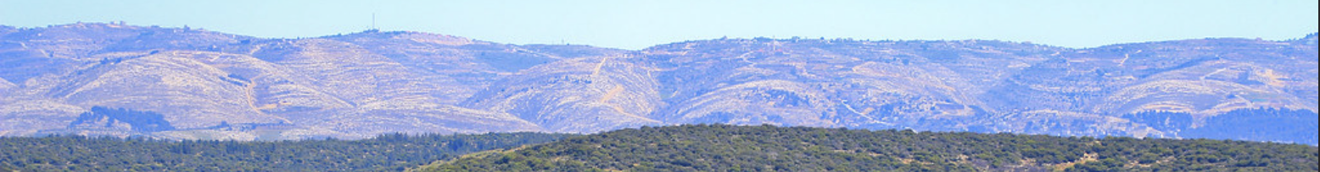 |  | > The overused Jordan River no longer leaps – and its diminished flow is choking off and killing the Dead Sea. | 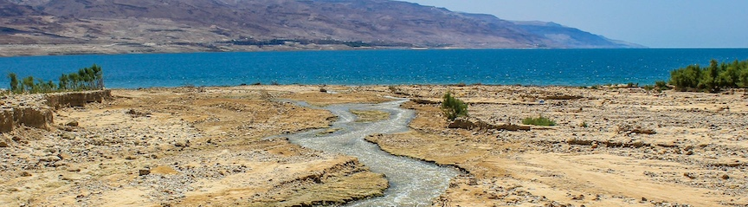
Psalm 114  >All the realms of Nature respond joyfully to redemption | B’tseit Yisra’el mimistrayim,  beit Ya`akov mei`am lo`eiz  Haytah Y’hudah l’kodsho, Yisra’el mamsh’lotav  Hayam ra’ah v’yanos, hayarden yisov l’achor  Heharim rak’du k’eilim, g’va’ot kiv’nei tson  Mah l’kha hayam ki tanus, hayarden tisov l’achor  Heharim tirk’du k’eilim, g’va`ot kiv’nei tson  Milifnei Adon chuli arets, milifnei Elo’ah Ya`akov  Hahofkhi hatsur agam mayim,  chalamish l’ma`yno mayim | בְּצֵאת יִשְׂרָאֵל מִמִצְרַיִם,  בֵּית יַעֲקֹב מֵעַם לֹעֵז,  הָיְתָה יְהוּדָה לְקָדְשׁוֹ, יִשְׂרָאֵל מַמְשְׁלוֹתָיו.  הַיָּם רָאָה וַיַּנֹס, הַיַּרְדֵּן יִסֹּב לְאָחוֹר.  הֶהָרִים רָקְדוּ כְאֵילִים, גְּבַעוֹת כִּבְנֵי צֹאן.  מַה לְּךָ הַיָּם כִּי תָנוּס, הַיַּרְדֵּן תִּסֹּב לְאָחוֹר,  הֶהָרִים תִּרְקְדוּ כְאֵילִים, גְּבַעוֹת כִּבְנֵי-צֹאן.  מִלְּפְנֵי אָדוֹן חוּלִי אָרֶץ, מִלְּפְנֵי אֱלוֹהַ יַעֲקֹב.  הַהֹפְכִי הַצּוּר-אֲגַם-מָיִם,  חַלָּמִיש לְמַעְיְנוֹ-מָיִם. |  | In Israel’s going forth from Egypt, Jacob’s house from a foreign people, Judah was God’s holiness, Israel God’s dominion. The sea saw and fled, the Jordan River turned round backwards. The mountains danced/leapt like rams, the hills like lambs of the flock. What’s with you, sea, that you would flee, you, Jordan, that you turn backwards? Mountains why dance like rams, hills like lambs of the flock? ~Before the Lord, the land is dancing/writhing/ in labor, before Jacob’s God, who transforms the rock into a pool of water, and flint into a spring of water.

This blessing completes the telling: | Blessed be You, YHVH our God, Ruler of all space-and-time, who redeemed us and redeemed our ancestors from Egypt, and who made us reach this night in which to eat matsah and maror. So may YHVH our God make us reach other celebrations and festivals coming to meet us, in peace, joyous in the building of Your city and rejoicing in Your service, [and there we will eat from the sacrifices and from the Pesach offerings, whose blood will reach up to the wall of Your altar according to (Your) desire,] and we will give thanks to You (with) a new song for our redemption and for the rescue of our souls. Blessed be You who redeems Israel. | בָּרוּךְ אַתָּה, יְהוָה אֱלֹהֵינוּ, מֶלֶךְ הָעוֹלָם, אֲשֶׁר גְּאָלָנוּ וְגָאַל אֶת אֲבוֹתֵינוּ מִמִּצְרַיִם, וְהִגִּיעָנוּ לַלַּיְלָה הַזֶּה לֶאֱכֹל בּוֹ מַצָּה וּמְרוֹרִים. כֵּן יְהוָה אֱלֹהֵינוּ וֵאלֹהֵי אֲבוֹתֵינוּ, יַגִּיעֵנוּ לְמוֹעֲדִים וְלִרְגָלִים אֲחֵרִים הַבָּאִים לִקְרָאתֵנוּ לְשָׁלוֹם, שְׂמֵחִים בְּבִנְיַן עִירָךְ וְשָׂשִׂים בַּעֲבוֹדָתָךְ, [וְנֹאכַל שָׁם מִן הַזְּבָחִים וּמִן הַפְּסָחִים שֶׁיַּגִּיעַ דָּמָם עַל קִיר מִזְבְּחָךְ לְרָצוֹן,] וְנוֹדֶה לְךָ שִׁיר חָדָשׁ עַל גְּאֻלָּתֵנוּ וְעַל פְּדוּת נַפְשֵׁנוּ. בָּרוּךְ אַתָּה יְהוָה, גּוֹאֵל יִשְׂרָאֵל. | This blessing includes a bloody image of sacrifice. Some people leave out those bracketed words.  Israel here means the people. But how should we pray for redemption of Israel the state and the land? Get a more just prayer here: neohasid.org/ resources/Prayer-state/
2nd cup – Magid | Drink the 2nd cup; don’t forget to recline! Ashkenazim say another blessing over wine here. Sefardim do not. | בָּרוּךְ אַתָּה, יְהוָה אֱלֹהֵינוּ, מֶלֶךְ הָעוֹלָם בּוֹרֵא פְּרִי הַגָּפֶן.
Rachtsah | Barukh Atah YHVH/Adonai Eloheinu melekh ha`olam asher kid’shanu b’mitsvotav v’tsivanu `al n’tilat yadayim.  Blessed be You…who made us holy through commandments, and commanded us about the uplifting of hands. | בָּרוּךְ אַתָּה, יְהוָה אֱלֹהֵינוּ, מֶלֶךְ הָעוֹלָם, אֲשֶׁר קִדְּשָׁנוּ בְּמִצְווֹתָיו, וְצִוָּנוּ עַל נְטִילַת יָדָיִם. | >A kavannah: In thanks for this water we use to uplift our hands, may we use our hands to keep the waters pure.
Stage directions for Motsi-Matsah | Here are the mechanics of the blessing: 1) Hold all three matsot together to make the hamotsi blessing for bread. 2) Drop the bottom whole matsah. 3) Make the blessing “`al akhilat matsah” on the top whole matzah and the middle broken matsah.  After the blessings, everyone should get some of the broken piece of matsah – the bread of slavery, and some of the top piece – the bread of leaving Egypt. It is customary to chew the first matsah in silence, to meditate on the taste and the experience. One is traditionally required to eat a substantial amount of matsah, “an egg’s volume”, so pieces of matsah from the top two matsot are usually supplemented with extra matsah.
Motsi | Barukh Atah Adonai Eloheinu melekh Ha`olam hamotsi lechem min ha’arets.  Blessed be You…who brings out bread from the land. | בָּרוּךְ אַתָּה, יְהוָה אֱלֹהֵינוּ, מֶלֶךְ הָעוֹלָם, הַמּוֹצִיא לֶחֶם מִן הָאָרֶץ. | It is a custom to not talk between washing, the blessings for motsi and for matsah, and the first taste of matsah, in order to unite all three as one act.
Matsah  Recline while eating | Barukh Atah Adonai Eloheinu melekh Ha`olam asher kid’shanu b’mitsvotav v’tsivanu `al akhilat matsah.  Blessed be You…who commanded us about eating matsah. | בָּרוּךְ אַתָּה, יְהוָה אֱלֹהֵינוּ, מֶלֶךְ הָעוֹלָם, אֲשֶׁר קִדְּשָׁנוּ בְּמִצְווֹתָיו, וְצִוָּנוּ עַל אֲכִילַת מַצָּה.
Maror  2nd dipping: Dip the maror in the charoset | Barukh Atah Adonai Eloheinu melekh Ha`olam asher kid’shanu b’mitsvotav v’tsivanu `al akhilat maror  Blessed be You…who commanded us about eating maror.  There are many plants one can use for maror: horseradish (most Ashkenazim), romaine lettuce (many Sefardim), chickory. I like to use dandelion greens. Though one is required to eat an “olive’s worth” in volume, many in Europe had the cutsom to eat a smaller amount of horseradish. | בָּרוּךְ אַתָּה, יְהוָה אֱלֹהֵינוּ, מֶלֶךְ הָעוֹלָם, אֲשֶׁר קִדְּשָׁנוּ בְּמִצְווֹתָיו, וְצִוָּנוּ עַל אֲכִילַת מָרוֹר. | Don’t recline – it’s the taste of slavery!
Maror  2nd dipping: Dip the maror in the charoset |  | The charoset is used to lessen the bitterness or burning, or, to remember the apple (tapuach), where the Israelite women seduced the men and where they gave birth, or to remember the mud, which used to make bricks, or to remember the blood. Charoset can represent eros, see Rabbi Arthur Waskow, opensiddur.org/haggadot/passover-seder/the-seders-innermost-secret. Charoset can also represent all the unresolved parts of our lives that don’t fit into the seder’s orderly progression from slavery to freedom. See: neohasid.org/torah/mystery_of_charoset/

Korekh  3rd explanation of matsah:  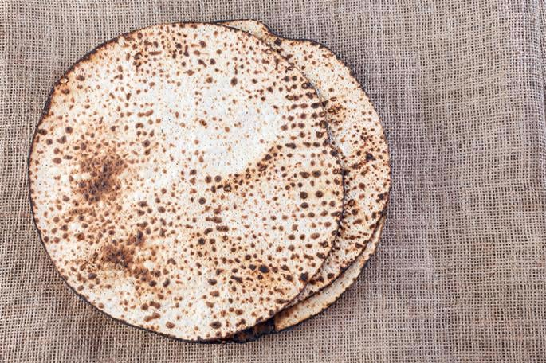 | A remembrance of the Mikdash/Holy Place/Sanctuary, according to Hillel. So did Hillel in the time that the House of the Sanctuary/Beit Hamikdash (Temple) was standing. He would sandwich matsah and maror together to uphold what is said: On matsot and bitters you will eat it (the Pesach lamb). (Exod. 12:8)  Everyone gets a piece of the bottom matsah for the sandwich. |  |  | זֵכֶר לְמִקְדָּשׁ כְּהִלֵּל. כֵּן עָשָׂה הִלֵּל בִּזְמַן שֶׁבֵּית הַמִּקְדָּשׁ הָיָה קַיָּם.  הָיָה כּוֹרֵךְ מַצָּה וּמָרוֹר וְאוֹכֵל בְּיַחַד, לְקַיֵּם מַה שֶּׁנֶּאֱמַר: ״עַל מַצּוֹת וּמְרוֹרִים יֹאכְלֻהוּ״ (שמות יב:ח)  Hillel quotes the verse describing the first Pesach in Egypt, when the Israelites were redeemed. |  |  | Korekh is the matsah of the Temple, the redemption of the past, which didn’t last. It is sweet and bitter, and so we eat it with maror, and with charoset.
Shulkhan `Orekh  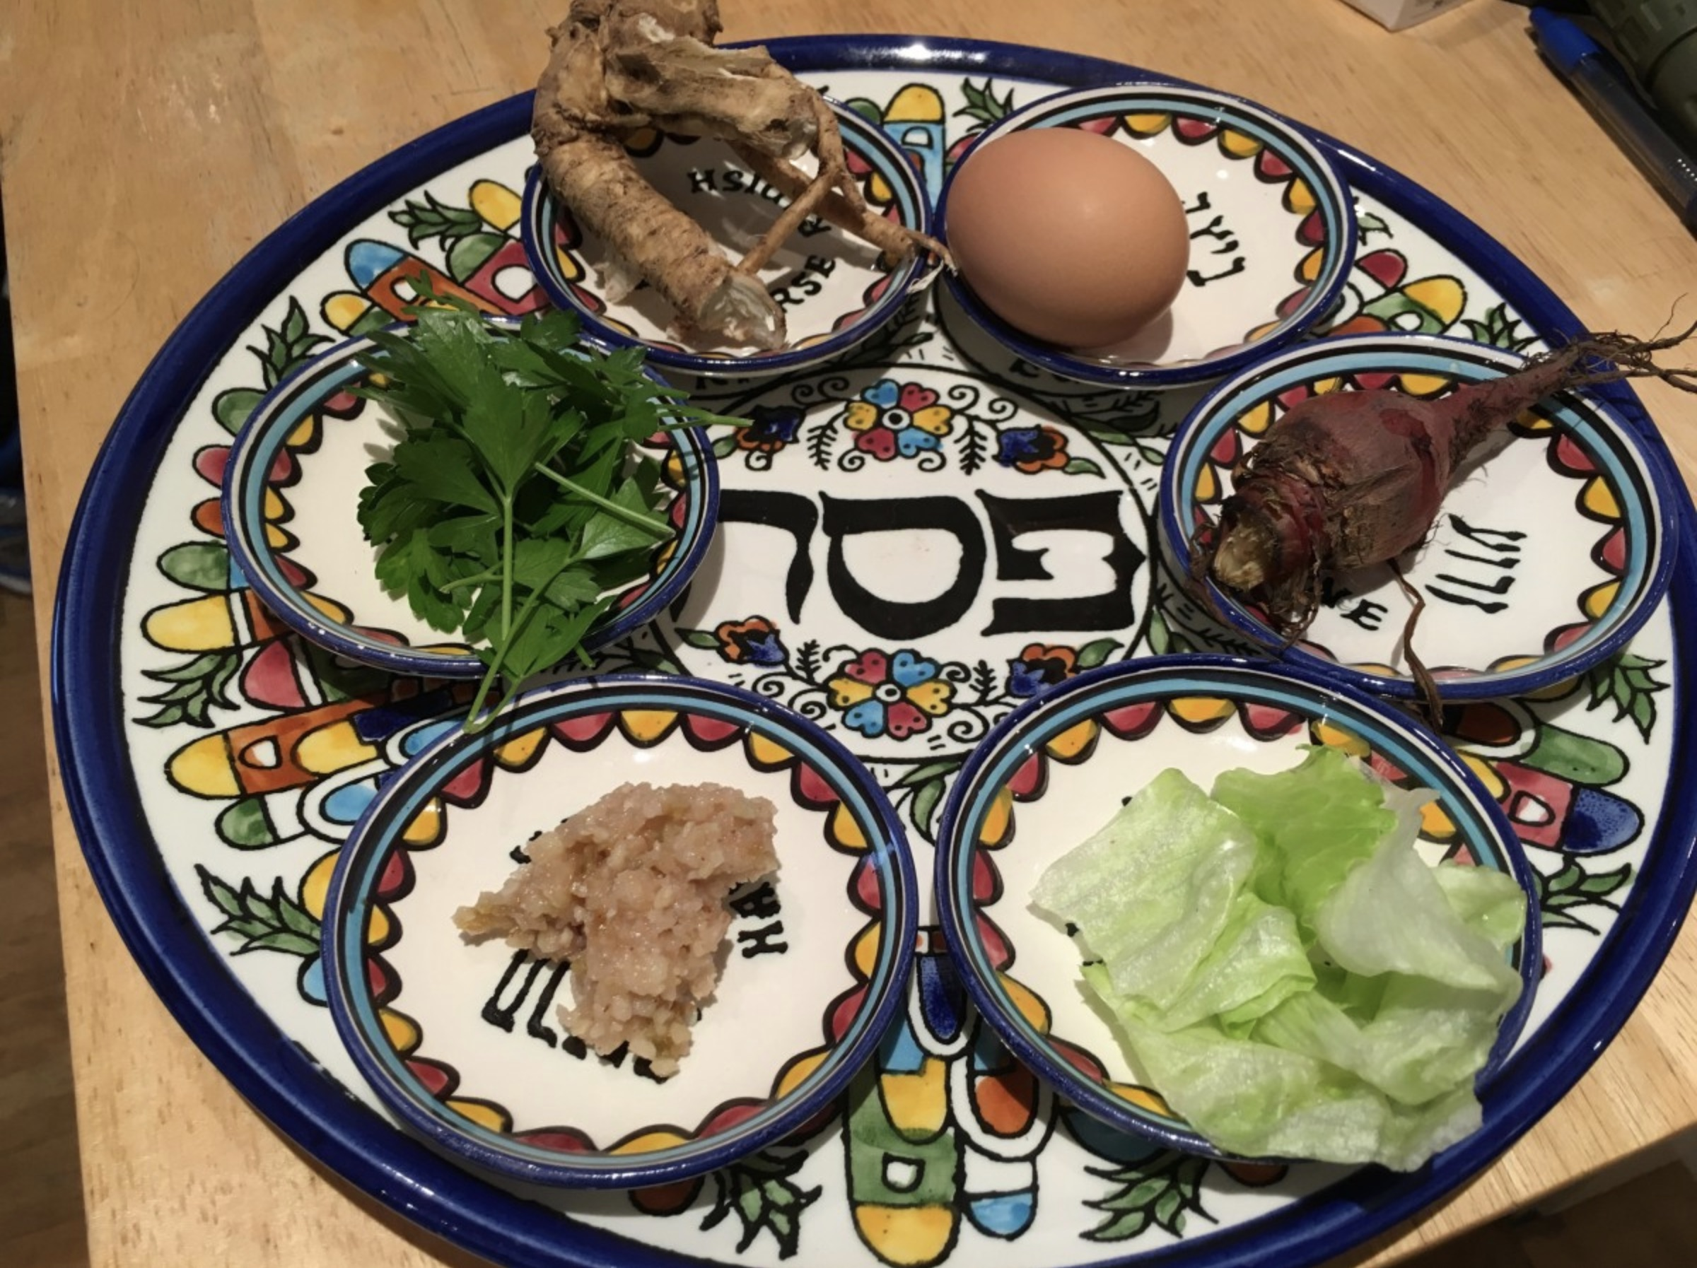 | Enjoy the meal, sing, discuss, make it a symposium on freedom – freedom then and freedom now. How can we bring freedom into this world? How can we release people who are enslaved? How can we protect refugees? How are we still enslaved?  >The One does justice for the orphan and the widow, and loves the stranger by giving them bread and clothing (lechem v’simlah). So you will love the stranger, for you were strangers in the land of Egypt. (Deut. 10:18-19)  >We live in a time very different from when the haggadah was written. Most importantly, Jews once again have sovereignty in the land of Israel. The haggadah pointedly leaves out the verse: “And God brought us unto this place, and gave to us this land, a land of flowing milk and honey.” Should we be adding this verse now? If not, why not? |  |  |  |  |  | > Can we really be free when we (the Jews) are ruling over another people (the Palestinians)?  > What freedom and what slavery arises when we imagine the land to be given solely to us?
Tsafun - the hidden one  Eat the afikoman  4th meaning of matsah: | This time we eat the matsah without any words. (Ashkenazim)  (Sefardim say:) Zekher l’korban Pesach hane’ekhal `al hasova`. A remembrance of the Pesach sacrifice, the one eaten upon fullness.  זֵכֶר לְקָרְבָּן פֶּסַח הָנֶאֱכַל עַל הָשּׂוֹבַע. |  | The afikoman is the fourth matsah, the hidden one, the missing half that completes what is broken. It is the matsah of redemption. Just as “we don’t know what we will serve Hashem with until we come there” (Exod. 10:26) – this matsah is concealed. The justice and peace of redemption, when it comes, will far exceed what we can imagine. It is a taste of the matsah we will eat in the days and nights of Mashiach (Messiah) – which we let ourselves eat and savor even now. |  |  |  | Everyone should get a piece of the actual afikoman. If someone needs to leave early, send them home with a piece.
Barekh  Birkat Hamazon  Invitation to bless after the meal (Zimun):  Shir Hama`alot is sung by Ashkenazim before zimun. | Pour the third cup.  This is an abridged but halakhic version of Birkat Hamazon.  Please consult other haggadot for the complete blessings, Shir Hama`alot, etc. | Ashkenazi: Call: Chaveirai umorai v’rabotai n’vareikh!  (Yiddish: Rabosai mir velen bentschen!) Let’s bless!  Response: Y’hi sheim Adonai m’vorakh mei`atah ve`ad `olam! May the name be blessed!  Leader repeats: “Y’hi sheim…” and continues:  Birshutkhen uvirshutkhem (on Shabbat: uvir’shut shabbat hamalkah) – With your permssion: |  |  |  | Sefardi: Call: Hav lan v’nivrikh! Response: Shamayim!  Call: Birshut malka `ila’a kadisha (on Shabbat: uvir’shut shabbat malk’ta) uvirshut chaveirai umorai v’rabotai –  With the permission of the exalted Holy Ruler (and the Sabbath Queen) and of my friends and my teachers:  (Some add this response: Birshut shamayim! With the permission of heaven!)
 | Add “Eloheinu/our God” when there is a minyan | All: Leader calls: N’vareikh (in a minyan: Eloheinu) she’achalnu mishelo! Let us bless (our God) from whose we have eaten!  Response: Barukh (in a minyan: Eloheinu) she’achalnu mishelo uv’tuvo chayyinu! Blessed be the One (our God) from whose we have eaten and whose good is our life. Leader repeats: “Barukh (in a minyan: Eloheinu) she’achalnu…” and all continue:
1) First blessing: God feeds and sustains all creatures.  Sefardi nusach in (parentheses).  Ashkenazi nusach in [brackets]. | 1) Barukh Atah Adonai, Eloheinu melekh ha`olam, hazan et ha`olam kulo b’tuvo b’chein b’chesed uv’rachamim hu notein lechem l’khol basar, ki l`olam chasdo. Uv’tuvo ha gadol tamid lo chasar lanu v`al yechsar lanu mazon (tamid) l`olam va`ed. [Ba`avur sh’mo ha gadol] ki hu El zan um’farneis lakol (v’shulchano arukh lakol v’hitkin mich’yeh umazon) [umeitiv lakol umeichin mazon] l’khol b’riyotav asher bara (uv’rov chasadav, ka’amur: Potei’ach et yadekha umasbi`a l’khol chai ratson). Baruch Atah Adonai, hazan et hakol. |  |  |  | 1) Blessed be You YHVH our God ruler of all space-and-time, who feeds the entire world with goodness and grace and compassion, who gives bread to all flesh, for God’s kindness is forever, and in whose great goodness food has never been lacking for us and never will lack for us forever and beyond. [For the sake of the great name,] for this is the One, God, feeding and providing for all, (who sets a table of food and nourishment for all,) [who does good for all, preparing food] for all God’s creatures that the One created, (through great kindness,) as it says “Your hand You open and satisfy every life. Blessed be the One who feeds all.

Here is a brief version of the next three blessings of Birkat Hamazon:  2) Thanksgiving  3) Asking for compassion and mercy, with additions for Passover  > The third blessing is modified to include petitions for all creatures and the earth. It ends with building Jerusalem “through peace”.  4) Recognizing God as the source of all good.  Sefardi nusach is used as the foundation for the third and fourth blessings. | 2) Nodeh l’kha Adonai Eloheinu `al shehinchalta la’avoteinu ul’imoteinu erets chemdah tovah ur’chavah, v`al shehotseitanu Adonai Eloheinu mei’erets Mitsrayim uf’ditanu mibeit `avadim, v`al brit’kha, v`al Toratekha, v`al chayyim umazon shechonantanu – v’al hakol Adonai Eloheinu anachnu modim lakh um’varkhim otakh, kakatuv: “V’achalta v’sava`ta uveirachta et Adonai Elohekha `al ha’arets hatovah asher natan lakh”. Barukh Atah Adonai `al ha’arets v`al hamazon.  3) Racheim na Adonai Eloheinu `al Yisrael (`amakh) [`amekha] v`al Y’rushalayim (`irakh) [`irekha] v`al har tsiyon, she-y’hei mishkan (k’vodakh) [k’vodekha], v’racheim `al kol `olamakh, r’fa’einu parn’seinu v’kalkaleinu, v’hagein `al kol b’riyotekha yuchaseinu viy’farn’seim v’harvach l’khulanu. Chadeish na p’nei ha’adamah v’hatsmi’ach ar’tsekha b’shalom v’mal’khutekha b’mishpat, bim’heirah v’yameinu.  (on Shabbat:) R’tsei v’chalitseinu b’yom hashabat hazeh v’har’einu Adonai Eloheinu b’nechemat Tsiyon irekha, ki atah hu ba`al hay’shu`ot uva`al hanechamot. (for the holiday:) Eloheinu vEilohei horeinu, ya`aleh v’yavo v’yagi`a v’yeira’eh v’yeiratseh v’yishama` v’yipakeid vizakheir zikhroneinu ufik’doneinu v’zikhron horeinu v’zikhron kol `amkha l’fanekha l’chayyim tovim ul’shalom b’yom chag hamatsot hazeh l’racheim bo ul’hoshi`einu.  Barukh Atah Adonai boneh b’shalom Y’rushalayim.  4) Barukh Atah Adonai Eloheinu melekh ha`olam ha’El avinu imeinu om’neinu bor’einu go’aleinu k’dosheinu, k’dosh Ya`akov, ro`einu, ro`eh Yisrael, hamelekh hatov v’hameitiv lakol, sheb’khol yom vayom hu heitiv, hu meitiv, hu yeitiv lanu, hu yig’m’leinu chen v’chesed revach v’rachamim v’hatsalah v’khol tuv. |  | 2) We give thanks to You YHVH our God for giving our ancestors a good wide land, and for bringing us out of Egypt and redeeming us from a domain of slaves, and for Your covenant and Your Torah, and for the life and food you have granted us – and for all, YHVH our God we thank You and bless You, as it says, “You will eat and be full/satisfied and bless YHVH Your God for the good land that the One gave to you”. Blessed be You YHVH for the land and for the food.  3) Have compassion/mercy please YHVH our God on Israel Your people and on Jerusalem Your city and on Mt. Zion, that may it become the dwelling place of Your glory, and have compassion on all Your world, our healer, our provider and our sustainer, and protect all Your creatures, our relations, and sustain them, make abundance for all of us. Renew the face of the earth, please, and make Your land bloom with peace and Your reign with justice – soon and in our days.  (add on Shabbat:) Accept and strengthen us on this Sabbath day and allow us to see, YHVH our God, the comforting of Zion Your city, for You are the master of saving and comforting. (for the holiday:) Our God and God of our ancestors, may our remembrance arise and come and reach and be seen and desired and be heard and recalled and remembered, and the remembrance of our ancestors and of all Your people, before You for good life and peace, on this holy day of matsot, to fill it with compassion and to save us.  Blessed be You YHVH, who builds Jerusalem through peace.  4) Blessed be You YHVH our God, ruler of all space-and-time, our Father, our Mother, who nourishes us, who creates us, who redeems us, our Holy One, Jacob’s Holy One, our shepherd, Israel’s shepherd, the good ruler who does good to all – in every day the One did good, does good, will do good for us, the One will return to us blessings of grace and love, abundance and mercy and rescue, and all goodness.
These petitions are a compendium of Harachaman prayers. Here and above “our fathers” is replaced with either “our fathers and our mothers” or “our parents”. | Harachaman hu yimlokh `aleinu viyshtabach banu viy’farn’seinu b’khavod v’yishlach b’rakhah m’rubah b’khol ma`aseh yadeinu. Harachaman hu yirpa’einu viy’tein shalom beineinu v’yishbor `oleinu viyta` torato b’libeinu v’yolikheinu kom’miyut la’arets Harachaman hu yivaser lanu b’sorot tovot y’shu`ot v’nechamot. Harachaman hu y’vareikh kol echad v’echad mimenu k’mo shenit’barkhu avoteinu v’imoteinu, ken y’vareikh otanu kulanu yachad biv’rakhah sh’leimah v’no’mar Amen.* Harachaman hu yanchileinu (on shabbat: yom shekulo shabbat), yom shekulo tov, viychayyeinu limot hamashiach ul’chayyei ha`olam haba. `Oseh shalom bimromav hu ya`aseh shalom `aleinu v`al kol Yisrael v`al kol yosh’vei teivel v’imru, Amen! Adonai `oz l`amo yitein, Adonai y’vareikh et `amo vashalom |  | May the compassionate One/Harachaman rule over us and be praised through us and provide for us with honor and send abundant blessing into all the work of our hands. Harachaman, heal us and make peace between us, break our yoke and plant the Torah in our hearts, and lead us uprightly to the land. Harachaman, bring us good news of salvation and comfort. Harachaman, bless every one of us as the One blessed our ancestors – so may the One bless us all together with complete blessing, and let us say, Amen! Harachaman, let us inherit (on shabbat: a day that is all shabbat,) a day that is all good, and bring us alive to Messianic days and the coming world. The One who makes peace in the heights will make peace for us and all Israel and all who inhabit the world and say, Amen! YHVH will give the people strength; YHVH will bless the people with peace.
> For Shmitah year (next one is in 2029): | * May the merciful One turn our hearts toward the land, so that we may dwell together with her in her sabbath-rest during the whole Shmitah year. | הָרַחֲמָן הוּא יָשִיב לִבֵּינו אֶל הָאָרֶץ לְמַעַן נֵשֵב יָחַד עִמָה בְשָבְתה כָל שְנַת הַשְמִיטָה |  | Learn a nigun/melody for this prayer: neohasid.org/resources/shmita-harachaman/
3rd cup – for Birkat Hamazon | Drink the 3rd cup at the end of the blessings!  Sefardim and Ashkenazim both bless over the 3rd cup. | בָּרוּךְ אַתָּה, יְהוָה אֱלֹהֵינוּ, מֶלֶךְ הָעוֹלָם בּוֹרֵא פְּרִי הַגָּפֶן.  Don’t forget to recline! |  | Barukh Atah Adonai Eloheinu melekh ha`olam borei’ p’ri [hagafen] (hagefen).

Open the door for Elijah  Here people traditionally recite Shfokh Chamatkha, “Pour Your fierce anger”.  The fourth cup may be filled before or after Shfokh Chamatkha. | Pour Your fierce anger onto the nations that did not know You and on the governments that did not call in Your name. For it has eaten Jacob and made his habitat desolate. (Psalms 79:6-7) Pour on them Your fury and make You burning anger grip them. (Psalms 69:25) Pursue in anger and destroy them from under YHVH’s heavens. (Lament. 3:66)  > My custom is to go outside when the door is opened, recite Sh’fokh Chamat’kha aloud, and pour out the bowl of plagues from earlier in the seder onto the ground, with the kavanah (intention/consciousness) that the earth has the power to heal plagues, and that even our worst feelings can be turned into something fertile and life-giving. |  | שְׁפֹךְ חֲמָתְךָ אֶל הַגּוֹיִם אֲשֶׁר לֹא יְדָעוּךָ וְעַל מַמְלָכוֹת אֲשֶׁר בְּשִׁמְךָ לֹא קָרָאוּ כִּי אָכַל אֶת יַעֲקֹב וְאֶת נָוֵהוּ הֵשַׁמּוּ. (תהילים עט:ו-ז) שְׁפָךְ עֲלֵיהֶם זַעֲמֶךָ וַחֲרוֹן אַפְּךָ יַשִּׂיגֵם (תהילים פט:כה) תִּרְדֹף בְּאַף וְתַשְׁמִידֵם מִתַּחַת שְׁמֵי יְהוָה (איכה ג:סו)  An alternative to this paragraph popularized by A Different Night reads, “Pour out Your love on the nations who have known you and on the realms who call upon your name. For they show love to the seed of Jacob and they defend your people Israel from those who would devour them alive.” | Many liberal haggadot leave out this paragraph, which calls on God to destroy the nations. But we need to do something with the anger we rightly feel when thinking about Jewish history, including October 7. Should we act out a desire for vengeance? The haggadah instead asks God to take our anger from us and find its proper use. This can only work if we make the moment cathartic, and not about hardening our anger or fear.
Elijah’s cup  The fifth cup can also represent bringing home the hostages. | Pour a fifth cup “for Elijah”.  We can only welcome Elijah after we have placerd our anger in God’s custodianship and let it go. Only then can we come into “the land” in a manner that is redemptive, as it says, “I will bring you into the land”. |  | The Talmud debates whether there should be four or five cups, corresponding to the steps of redemption mentioned in Exodus 6:6-8: “I will take you out”, “I will rescue you”, “I will redeem you”, “I will take you for Myself”, and “I will bring you into the land”. We haven’t merited the fifth stage yet, hence the debate. Since all such debates will be settled by Elijah the prophet when he returns to announce the Messiah, the fifth cup became “Elijah’s cup”.
Hallel  Transliteration only |  | The Hallel psalms and other songs can be found in most haggadot. Hallel is recited over the 4th cup. | The fun seder songs, like Adir Hu, Echad Mi Yode`a, and Chad Gadya can go here or after Nirtsah. Consult other haggadot for songs and for full translations of Hallel.
Psalm 115, part 1  Not for us, YHVH, not for us – but for Your Name, give glory… Having awe for YHVH, trust in YHVH  Psalm 115, part 2 YHVH remember us! Bless the house of Israel…Halleluyah!  Psalm 116, part 1 Return, my soul, to your place of rest, for YHVH bestows grace over you.  Psalm 116, part 2 Answer YHVH! – for I am Your servant…  Psalm 117 Praise YHVH, all nations! For love has over-come us, Halleluyah! |  | Lo lanu, Adonai, lo lanu, ki l’shimkha tein kavod, `al chasd’kha `al amitekha. Lamah yomru hagoyim, ayeh na Eloheihem vEiloheinu vashamayim, kol asher chafeits `asah. Atsabeihem kesef v’zahav, ma`aseh y’dei adam. Peh lahem v’lo y’dabeiru, einayim lahem v’lo yiru. Oznayim lahem v’lo yishma`u, af lahem v’lo y’richun. Y’deihem v’lo y’mishun, ragleihem v’lo y’haleikhu, lo yehgu bigronam. K’mohem yihyu `oseihem, kol asher botei’ach bahem.  Yisrael b’tach bAdonai, `ezram umaginam hu. Beit Aharon bit’chu vAdonai,` ezram umaginam hu. Yir’ei Adonai bit’chu vAdonai, `ezram umaginam hu.  Adonai z’kharanu y’vareikh, y’vareikh et beit Yisrael, y’vareikh et beit Aharon. Y’vareikh yir’ei Adonai, hak’tanim `im hag’dolim. Yoseif Adonai `aleikhem, `aleikhem v`al b’neikhem. B’rukhim atem lAdonai, `oseh shamayim va’arets. Hashamayim shamayim lAdonai, v’ha’arets natan livnei adam. Lo hameitim y’hal’lu yah, v’lo kol yor’dei dumah. Va’anachnu n’vareikh yah, mei`atah v`ad `olam. Hal’luyah.  Ahavti ki yishma` Adonai, et koli tachanunai. Ki hitah ozno li, uv’yamai ekra. Afafuni chevlei mavet, um’tsarei sh’ol m’tsa’uni, tsarah v’yagon emtsa. Uv’sheim Adonai ekra: Anah Adonai maltah nafshi! Chanun Adonai v’tsadik, vEiloheinu m’racheim. Shomer p’ta’im Adonai, daloti v’li y’hoshi`a. Shuvi nafshi lim’nuchaikhi, ki Adonai gamal `alaikhi. Ki chilats’ta nafshi mimavet, et eini min dim`ah, et ragli midechi. Et’haleikh lifnei Adonai, b’ar’tsot hachayyim. He’emanti ki adabeir, ani `aniti m’od. Ani amarti v’chof’zi, kol ha’adam kozev.  Mah ashiv lAdonai, kol tagmulohi `alai. Kos y’shu`ot esa, uv’sheim Adonai ekra. N’darai lAdonai ashaleim, negdah na l’khol `amo. Yakar b`einei Adonai, hamavtah lachasidav. `Anah Adonai ki ani `avdekha, ani `avd’kha ben amatekha, pitachta l’moseirai. L’kha ezbach zevach todah uv’sheim Adonai ekra. N’darai lAdonai ashaleim negdah na l’chol `amo. B’chats’rot beit Adonai, b’tokheikhi Yerushalayim, hal’luyah.  Hal’lu et Adonai, kol goyim, shab’chuhu, kol ha’umim. Ki gavar `aleinu chasdo, ve’emet Adonai l`olam, hal’luyah.

Psalm 118  Give thanks…for God’s love is forever.  From the narrow strait I called Yah, and the One answered me from Yah’s expanse.  Open to me the gates of righteousness – I will come in thanking Yah!..Please YHVH save us! Please YHVH rescue us! Give thanks…for God’s love is forever. | Hodu lAdonai ki tov, ki l`olam chasdo. Yo’mar na Yisrael ki l`olam chasdo. Yo’mru na veit Aharon ki l`olam chasdo. Yo’mru na yir’ei Adonai, ki l`olam chasdo.  Min hameitsar karati yah, `anani vamerchav yah. Adonai li lo ira’, mah ya`aseh li adam? Adonai li b`ozrai, va’ani ereh b’son’ai. Tov lachasot bAdonai, mib’to’ach ba’adam. Tov lachasot bAdonai, mib’to’ach bin’divim. Kol goyim s’vavuni, b’sheim Adonai ki amilam. Sabuni gam s’vavuni, b’sheim Adonai ki amilam. Sabuni khid’vorim do’achu k’eish kotsim, b’sheim Adonai ki amilam. Dachoh d’chitani linpol, vAdonai `azarani. `Ozi v’zimrat yah, vay’hi li lishu`ah. Kol rinah vishu`ah b’ohalei tsadikim, y’min Adonai `osah chayil. Y’min Adonai romeimah, y’min Adonai `osah chayil. Lo amut ki echyeh, va’asapeir ma`asei yah. Yasor yis’rani yah, v’lamavet lo n’tanani.  Pitchu li sha`arei tsedek, avo vam odeh yah. Zeh hasha`ar lAdonai tsadikim yavo’u vo. (All the following lines are repeated:) Od’kha ki `anitani, vat’hi li lishu`ah. Even ma`asu habonim, haytah l’rosh pinah. Mei’et Adonai haytah zot, hi nifla’t b’eineinu. Zeh hayom `asah Adonai, nagilah v’nism’chah vo.  Ana Adonai hoshi`ah na. Ana Adonai hats’lichah na.  Barukh haba b’sheim Adonai, beirakhnukhem mibeit Adonai. El Adonai vaya’er lanu, isru chag ba`avotim `ad karnot hamizbei’ach. Eli atah v’odeka, Elohai arom’meka. Hodu lAdonai ki tov, ki l`olam chasdo. (up til here)
Blessing from the end of the daytime Hallel  This litany is called the Great Hallel because it continues with Psalm 136 and Nishmat. | Y’hal’lukha Adonai Eloheinu kol ma`asekha, v’chasidekha tsadikim `osei r’tsonekha, v’khol `amkha beit Yisrael b’rinah yodu viyvarkhu viy’shabchu viy’fa’aru, viyrom’mu v’ya`aritsu v’yakdishu v’yamlikhu et shimkha, malkeinu. Ki l’kha tov l’hodot ul’shimkha na’eh l’zamer, ki mei`olam Atah El. | 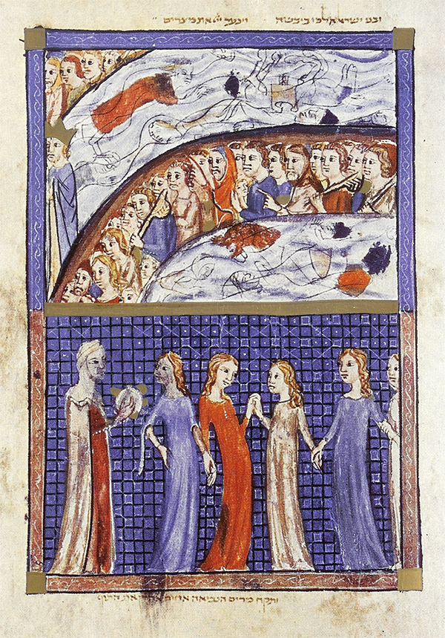  Crossing the sea, with Miriam and the women dancing, Sarajevo Hagggadah
Psalm 136  Give thanks to YHVH, for the One is good, for God’s love is forever…Who does great wonders, making the heavens, hammering out the firmament, making the great lights… Who strikes Egypt’s firstborn, and brings Israel out from their midst… Who divides the sea into divisions, bringing Israel through its midst, Who overthrows Pharaoh and his might in the sea of reeds… Who strikes down great kings, for God’s love is forever……Who in our lowliness remembers us, who breaks us free from our straits, who gives bread to all flesh…Give thanks to the God of the heavens, for God’s love is forever. | Hodu lAdonai ki tov, ki l`olam chasdo. Hodu lEilohei ha’elohim, ki l`olam chasdo. Hodu lAdonei ha’adonim, ki l`olam chasdo.  [Giving thanks for natural wonders:] L`oseh nifla’ot g’dolot l’vado, ki l`olam chasdo. L`oseh hashamayim bit’vunah, ki l`olam chasdo. L’roka` ha’arets `al hamayim, ki l`olam chasdo. L`oseh orim g’dolim, ki l`olam chasdo. Et hashemesh l’memshelet bayom, ki l`olam chasdo. Et hayareich v’kochavim l’memsh’lot balailah, ki l`olam chasdo.  [Giving thanks for redemption from slavery:] L’makeh Mits’rayim bivchoreihem, ki l`olam chasdo. Vayotsei’ Yisrael mitokham, ki l`olam chasdo. B’yad chazakah uvizro`a n’tuyah, ki l`olam chasdo. L’gozer yam suf lig’zarim, ki l`olam chasdo. V’he`evir Yisrael b’tokho, ki l`olam chasdo. V’ni`er par`oh v’cheilo b’yam suf, ki l`olam chasdo. L’molikh `amo bamidbar, ki l`olam chasdo.  [Thanks for other victories]: L’makeh m’lakhim g’dolim, ki l`olam chasdo. Vayaharog m’lakhim adirim, ki l`olam chasdo. L’sichon melekh ha’emori, ki l`olam chasdo. Ul`og melekh habashan, ki l`olam chasdo. Vanatan ar’tsam l’nachalah, ki l`olam chasdo. Nachalah l’Yisrael `avdo, ki l`olam chasdo.  [Thanks for divine love and care:] Sheb’shifleinu zakhar lanu, ki l`olam chasdo. Vayif’r’keinu mitsareinu, ki l`olam chasdo. Notein lechem l’khol basar, ki l`olam chasdo. Hodu l’El hashamayim, ki l`olam chasdo.

Blessing that ends Shabbat morning’s P’sukei D’zimra is said here.  The breath of every life will bless Your name…  Were our mouth song-filled like the sea, our tongue, glad-song, like the multitude of its waves…we could not finish thanking You…  From Egypt You redeemed us… You rescue the poor and impoverished… | Nishmat kol chai t’vareikh et shimkha, Adonai Eloheinu, v’ru’ach kol basar t’fa’er ut’romem zikhrekha, malkeinu, tamid. Min ha`olam v`ad ha`olam atah El, umibaladekha ein lanu melekh go`eil umoshi`a, podeh umatsil um’farnes um’rachem b’khol `eit tsarah v’tsukah. Ein lanu melekh ela atah. Elohei harishonim v’ha’achronim, Elo’ah kol briy’ot, Adon kol toldot, ham’hulal b’rov hatishbachot, ham’naheg `olamo b’chesed uv’riyotav b’rachamim. VAdonai lo yanum v’lo yiyshan – ham`orer y’sheinim v’hameikits nirdamim, v’hameisi’ach ilmim v’hamatir `asurim v’hasomeikh noflim v’hazokef k’fufim. L’kha l’vadkha anachnu modim.  Ilu finu malei shirah kayam, ul’shoneinu rinah kahamon galav, v’sif’toteinu shevach k’merkhavei raki`a, v`eineinu me’i’rot kashemesh v’khayarei’ach, v’yadeinu f’rusot k’nisrei shamayim, v’ragleinu kalot ka’ayalot – ein anachnu maspikim l’hodot lakh, Adonai Eloheinu vEilohei avoteinu, ul’vareikh et shimkha `al achat mei’elef alfei alafim v’ribei r’vavot p`amim hatovot she`asita `im imeinu v’avoteinu, v`imanu.  Mimitsrayim g’altanu, Adonai Eloheinu, umibeit `avadim p’ditanu, b’ra`av zantanu uv’sava` kil’kaltanu, meicherev hitsal’tanu umidever milat’tanu, umeichalayim ra`im v’ne’emanim dilitanu. `Ad heina `azarunu rachamekha v’lo `azavunu chasadekha, v’al tit’sheinu, Adonai Eloheinu, lanetsach. `Al kein eivarim shepilagta banu v’ru’ach unishamah shenafachta b’apeinu v’lashon asher samta b’finu – hein heim yodu viyvarkhu viyshab’chu viyfa’aru viyrom’mu v’ya`aritsu v’yak’dishu v’yamlikhu et shimkha malkeinu. Ki khol peh l’kha yodeh, v’khol lashon l’kha tishava`, v’khol berekh l’kha tikhra`, v’khol komah l’fanekha tishtachaveh, v’khol l’vavot yira’ukha, v’khol kerev ukh’layot y’zamru lishmekha, kadavar shekatuv, kol `atsmotai to’marna: Adonai, mi khamokha, matsil `ani meichazak mimenu v`ani v’evyon migozlo.
Who is like You, who can compare to You, Great, Mighty, Awesome One, who possesses heavens and the Earth. We praise and extol and beautify and bless Your holy Name…  Blessed be You, YHVH, God Ruler made great through praises… who is the life of all the worlds. | Mi yidmeh lakh umi yishveh lakh umi ya`arokh lakh ha’El hagadol, hagibor v’hanora’, El `elyon, konei shamayim va’arets. N’halel’kha un’shabeichakha un’fa’erkha un’vareikh et sheim kodshekha, k’amur: l’David, barkhi nafshi et Adonai v’khol krovai et sheim kodsho. Ha’El b’ta`atsumot `uzekha, hagadol bikh’vod sh’mekha, hagibor lanetsach v’hanora b’norotekha, hamelekh hayoshev al kisei ram v’nisa’.  Shokhein `ad marom v’kadosh sh’mo. V’katuv: ran’n’nu tsadikim b’Adonai, lay’sharim na’vah t’hilah. B’fi y’sharim tit’romam, uv’divrei tsadikim tit’barakh, uvilshon chasidim tit’kadash, uvkerev k’doshim tit’halal. Uv’mak’halot riv’vot `amkha beit Yisrael b’rinah yitpa’er shimkha, malkeinu, b’khol dor vador. Shekein chovat kol hay’tsurim l’fanekha, Adonai Eloheinu v’Elohei avoteinu v’imoteinu, l’hodot l’hallel l’shabei’ach l’fa’er l’romeim l’hader l’vareikh, l`alei ul’kaleis `al kol divrei shirot v’tishb’chot David ben Yishai avd’kha, mishichekha.  Yishtabach shimkha la`ad malkeinu, Ha’El hamelekh hagadol v’hakadosh bashamayim uva’arets, ki l’kha na’eh Adonai Eloheinu v’Elohei avoteinu v’imoteinu, shir ushvachah, haleil v’zimrah, `oz umemshalah, netsach, g’dulah ug’vurah, t’hilah v’tif’eret, k’dushah umalkhut, brakhot v’hoda’ot mei`atah v`ad `olam. Barukh Atah Adonai, El melekh gadol batishbachot, El hahoda’ot, Adon hanifla’ot, Habocher b’shirei zimrah, Melekh El chei ha`olamim.
4th cup  – for Hallel | Drink the 4th cup at the end of singing Hallel. Traditionally one also says the blessing that comes after drinking wine or grape juice here. | בָּרוּךְ אַתָּה, יְהוָה אֱלֹהֵינוּ מֶלֶךְ הָעוֹלָם בּוֹרֵא פְּרִי הַגָּפֶן. | Drink reclining! Sefardim traditionally don’t say a blessing over the fourth cup.
Nirtsah | Chasal sidur Pesach k’hilkhato, k’khol mishpato v’chukato. Ka’asher zachinu l’sader oto, ken nizkeh la`asoto. Zakh shokhen m’onah, komem k’hal `adat mi manah. B’karov nahel nit`ei khanah p’duyim l’tsiyon b’shalom b’rinah.  L’shanah haba’ah biy’rushalayim hab’nuyah!  Next year in Jerusalem, built (anew)! | חֲסַל סִדּוּר פֶּסַח כְּהִלְכָתוֹ, כְּכָל מִשְׁפָּטוֹ וְחֻקָּתוֹ. כַּאֲשֶׁר זָכִינוּ לְסַדֵּר אוֹתוֹ כֵּן נִזְכֶּה לַעֲשׂוֹתוֹ. זָךְ שׁוֹכֵן מְעוֹנָה, קוֹמֵם קְהַל עֲדַת מִי מָנָה. בְּקָרוֹב נַהֵל נִטְעֵי כַנָּה* פְּדוּיִם לְצִיּוֹן בְּשָׁלוֹם בְּצֶדֶק וּבְרִנָּה.  לְשָׁנָה הַבָּאָה בִּירוּשָלָיִם הַבְּנוּיָה  * from Psalm 80:16 (15), וכנה אשר נטעה ימינך | The Pesach order has been unfolded according to its law, justice and statute. As we merited to (tell in) order (the story), so may we merit to do (the sacrifice). Pure One dwelling (in the) exalted place, sustain the community of the congregation, who can count them? Soon lead those plantings of the stock, redeemed, to Zion in peace, with justice and with glad song.

Count the Omer at the second seder  For the Omer Counter app and more omer resources, go to: neohasid.org/resources/omer/ | Blessed be You, YHVH our God, ruler of all space-and-time, who made us holy through commandments and commanded us about counting the Omer.  Tonight is the first night of the Omer, Love within Love.  Counting the Omer can happen anytime during the seder. Do it earlier if that’s when people will be there to participate. Learn a Hasidic dance nigun for counting on neohasid.org. | בָּרוּךְ אַתָּה, יְהוָה אֱלֹהֵינוּ מֶלֶךְ הָעוֹלָם אֲשֶׁר קִדְּשָׁנוּ בְּמִצְווֹתָיו וְצִוָּנוּ עַל סְפִירַת הָעֹמֶר  הָיּוֹם יוֹם אֶחָד בָּעוֹמֵר | לָעוֹמֵר  Hayom yom echad ba`omer | la`omer  חֶסֶד שֶׁבְּחֶסֶד Chesed sheb’chesed  Sefardim and Hasidim say ba`omer. Most other Ashkenazim say la`omer. | Use neohasid.org’s Omer counter app for Android or iOS to count your way to Shavuot! You’ll find English, transliteration and Hebrew for each day of counting, and quotes connecting to each day and its Kabbalistic symbolism.
 |  |  | 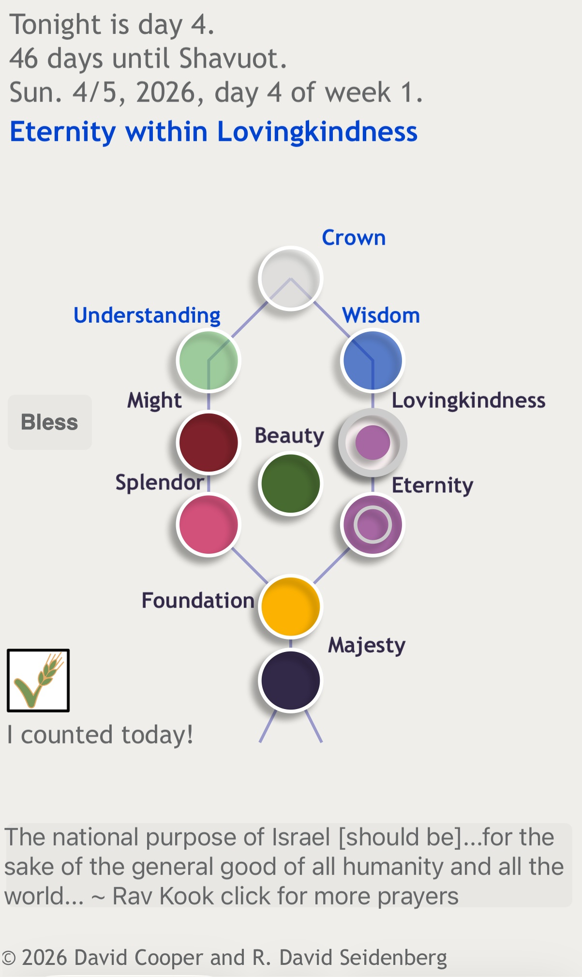
Haggadah of the Inner Seder | >May we be blessed with liberation, freedom from fear and want, the freedom to act and create, and the power and wisdom to live in harmony and love, with honor towards all Creation and our fellow creatures.
OMER COUNTER APP, with quotes for each day – https://www.neohasid.org/omer/apps/
for iOS and Android
Download Earth prayers for Earth Day from neohasid.org, including Hebrew of Pope Francis’s ecumenical prayer and much more – go to: https://neohasid.org/resources/earthprayers/.

Download this haggadah from: http://neohasid.org/zman/pesach/InnerSeder/ Please send feedback to rebduvid86@gmail.com. Go to neohasid.org to make a donation for this Haggadah and other resources! Teachings on Jews and indigenousness, go to: youtube.com/@neohasid.

> Prayer for the land of Israel: neohasid.org/resources/Prayer-state/
> Prayer for democracy: neohasid.org/resources/democracy/

Rabbi David Seidenberg is the author of Kabbalah and Ecology: God’s Image in the More-Than-Human World (Cambridge University Press, 2015) and the creator of neohasid.org.

Please do not print or distribute without including this page.

